DOKUMENTACIJA – WEB PROGRAMIRANJE 1

**Link:** https://vukasin-antic.github.io/GameHaven/index.html



**Ime i prezime:** Vukasin Antic

**Indeks:** 65/23

Contents

Uvod 2

Sajt 2

Opis sajta 2

XML kod 3

Slike sajta 3

Kodovi HTML 16

Index.html 16

shop.html 16

contact-us.html 16

author.html 16

CSS 16

Style.css 16

JavaScript 26

Main.js 26

Contact.js 45

# Uvod

## Sajt

Sajt je napravljen koriscenjem: HTML, CSS, Bootstrap, JavaScript, jQuery.

## Opis sajta

Index.html

* Dinamicki ispis menija
* Dinamicki ispis “Slider” (region slajder na pocetnoj strani)
* Dinamicki ispis “Services” (region servisa)
* Dinamicki ispis „FACTS“ (region cifre)
* Dinamicki ispis „Trending games“ (region trending games)
* Dinamicki ispis modala (ispisuju se na dnu stranice pre footer-a)
* Prikaz modala kod Trending games(see more) pomocu jQuery
* Dinamicki ispis „Latest games...“ (region Latest games...)
* Dinamicki ispis „Games“ (region Shop)
* Filter za shop pomocu jQuery
* Dinamicki ispis klijenta (region Clients)
* Regularni izrazi za ime, prezime (samo slova, pocinju velikim slovom, max 15), imejl(zavrsava se na @gmail.com ili @yahoo.com ili @ict.edu.rs)
* Validacija cele forme, ispis gresaka kod polja gde je unos pogresan, poruka o uspesnom slanju podataka ukoliko je sve uneto ispravno
* Kod radio button-a obavezan jedan selektovan
* Kod checkbox-a drugi “I agree...” je obavezan za selektovanje
* Dinamicki ispis FaQ (region )

## XML kod

<?xml version="1.0" encoding="utf-8"?>

    <urlset xmlns="http://www.sitemaps.org/schemas/sitemap/0.9">

        <url>

            <loc>https://vukasin-antic.github.io/GameHaven/index.html</loc>

            <lastmod>2024-05-12</lastmod>

            <changefreq>daily</changefreq>

            <priority>1</priority>

        </url>

        <url>

            <loc>https://vukasin-antic.github.io/GameHaven/shop.html</loc>

            <lastmod>2024-05-12</lastmod>

            <changefreq>weekly</changefreq>

            <priority>0.8</priority>

        </url>

        <url>

            <loc>https://vukasin-antic.github.io/GameHaven/contact-us.html</loc>

            <lastmod>2024-05-12</lastmod>

            <changefreq>weekly</changefreq>

            <priority>0.8</priority>

        </url>

        <url>

            <loc>https://vukasin-antic.github.io/GameHaven/author.html</loc>

            <lastmod>2024-05-12</lastmod>

            <changefreq>monthly</changefreq>

            <priority>0.5</priority>

        </url>

</urlset>

## Slike sajta

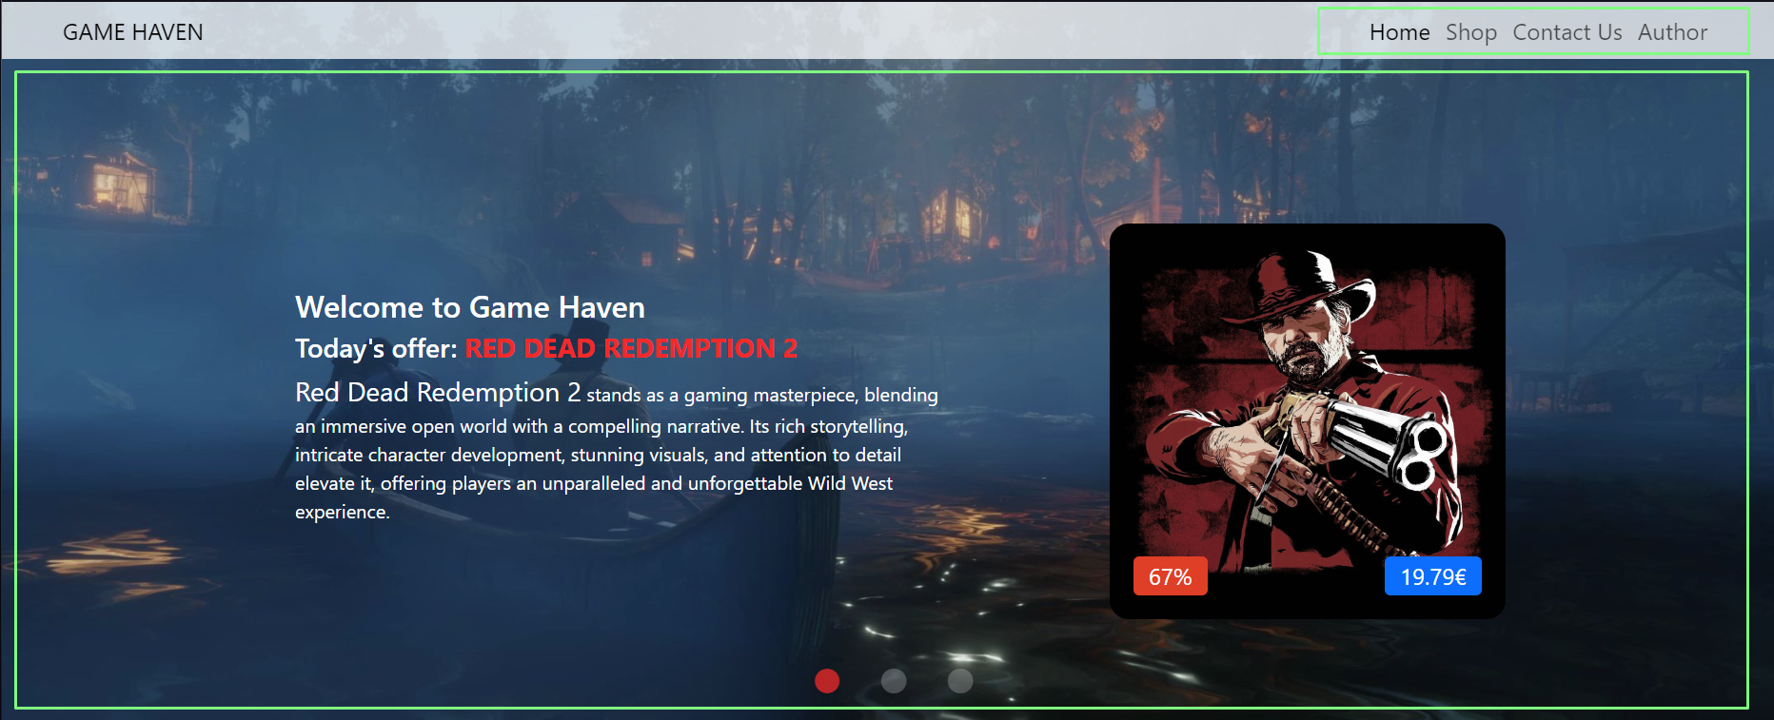

Dinamicki ispisan meni i slajder koji su napravljeni pomocu niza objekata i funkcije koja kreira elemente tako sto prima objekte iz niza jedan po jedan uz pomoc petlje. Slajder napisan uz pomoc slick jQuery biblioteke

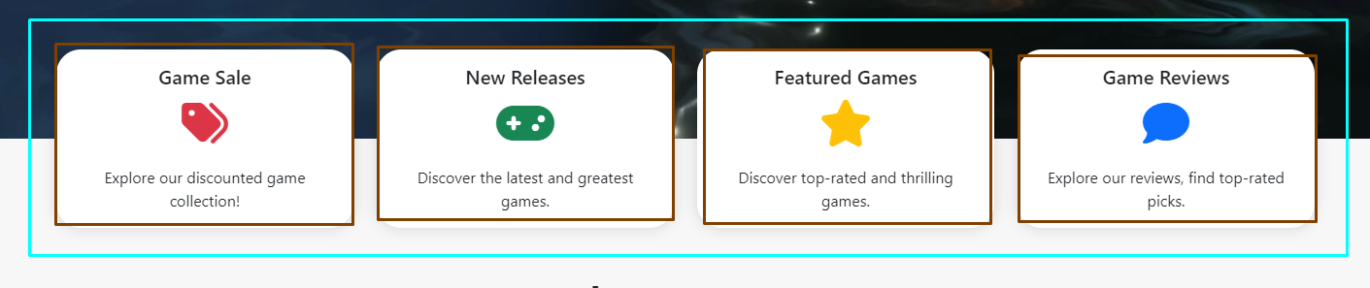

Dinamicki ispisan region Services

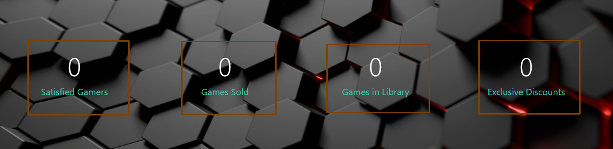

Dinamicki ispisan region Facts u kojem se nalaze cifre koje se pomocu funkcije ucitavaju kada se dodje do tog dela na sajtu



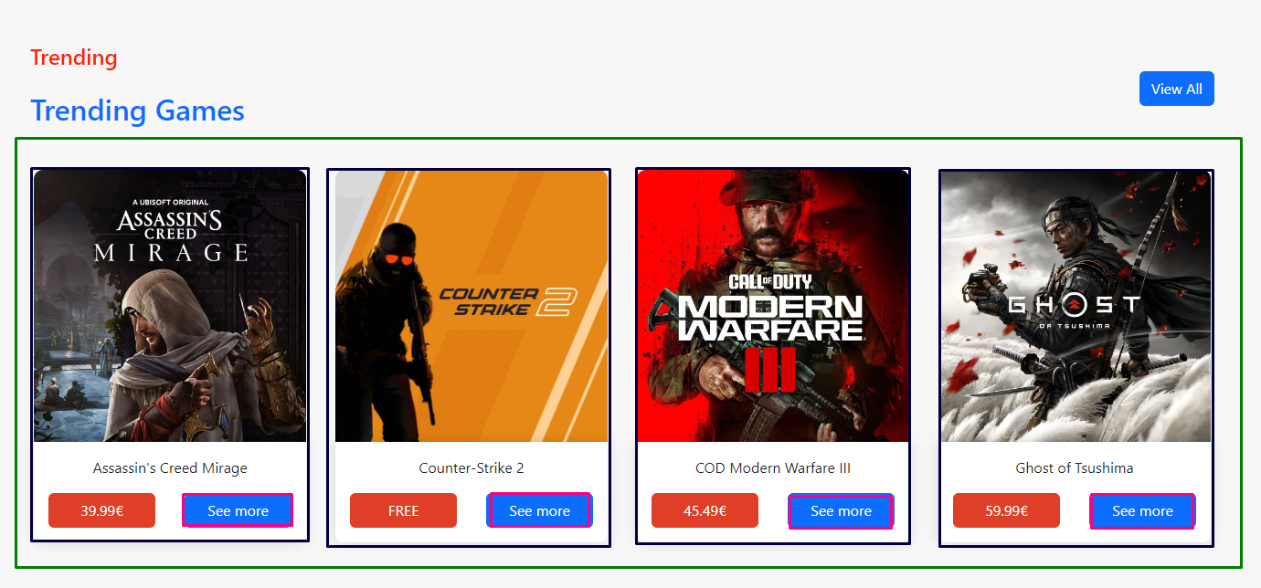

Dinamicki ispisan region Trenging, klikom na See more se pojavljuju modali koji su takodje dinamicki ispisani, klikom na View All se odlazi na stranicu Shop.html gde se nalaze ostale igrice

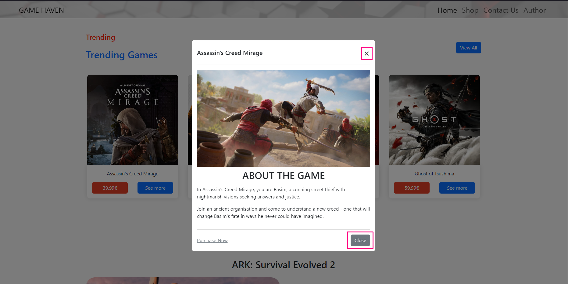

Na close ili „X“ se izlazi iz modala, ili prilikom klika van njega bilo gde na stranici

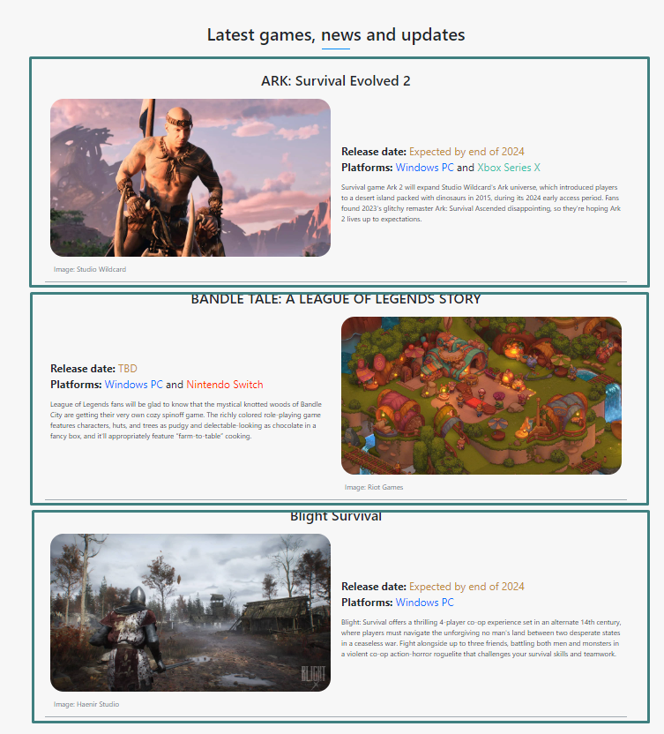

Dinamicki ispisan region Latest games...

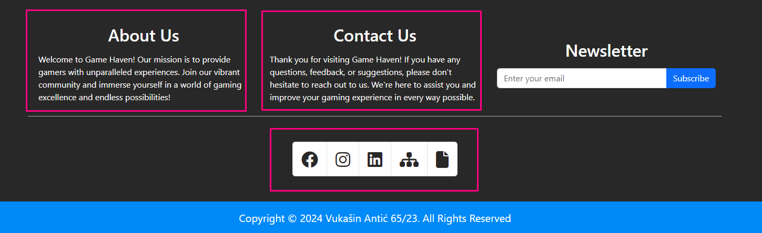

Dinamicki ispisan deo „About Us“ , „Contact Us“ , i lista ikonica u footer-u

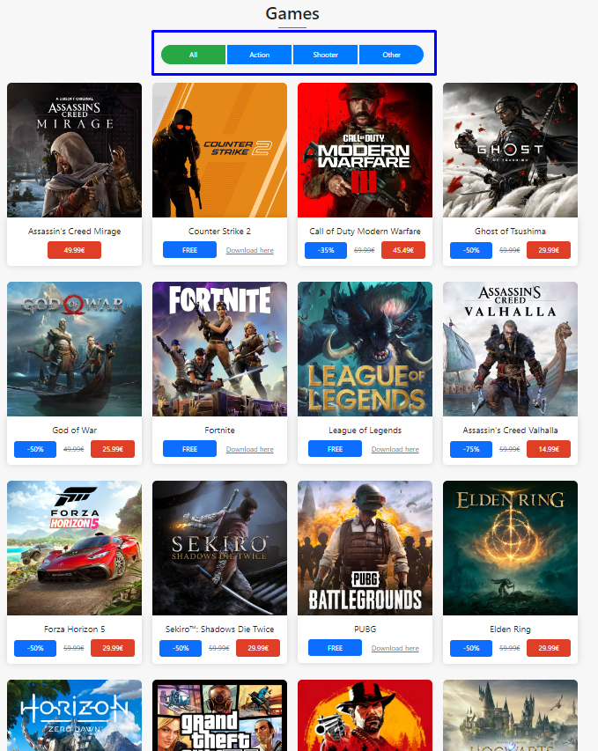

Dinamicki ispisni blokovi za igrice koji se filtriraju pri klikom na buttone iznad koji su napisane uz pomoc isotope jQuery

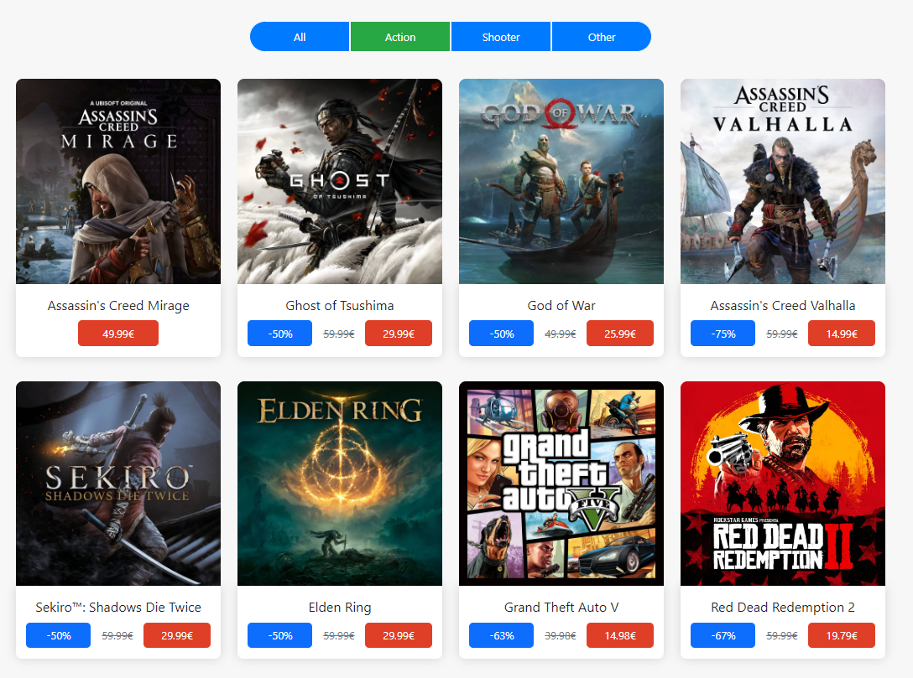 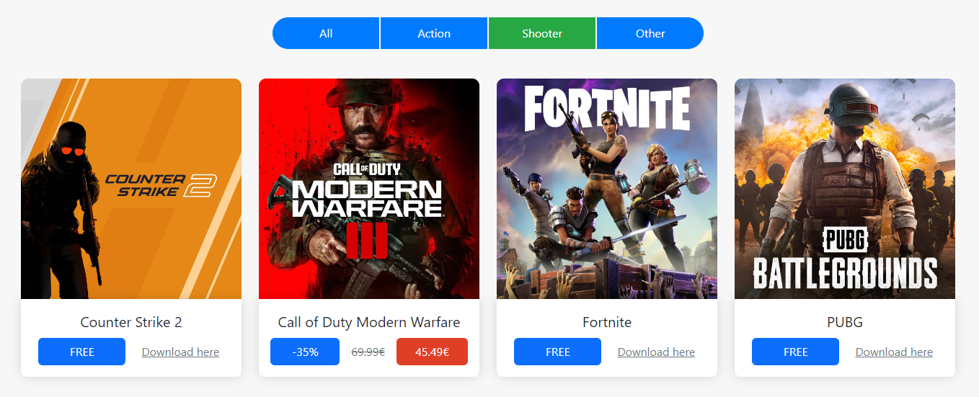 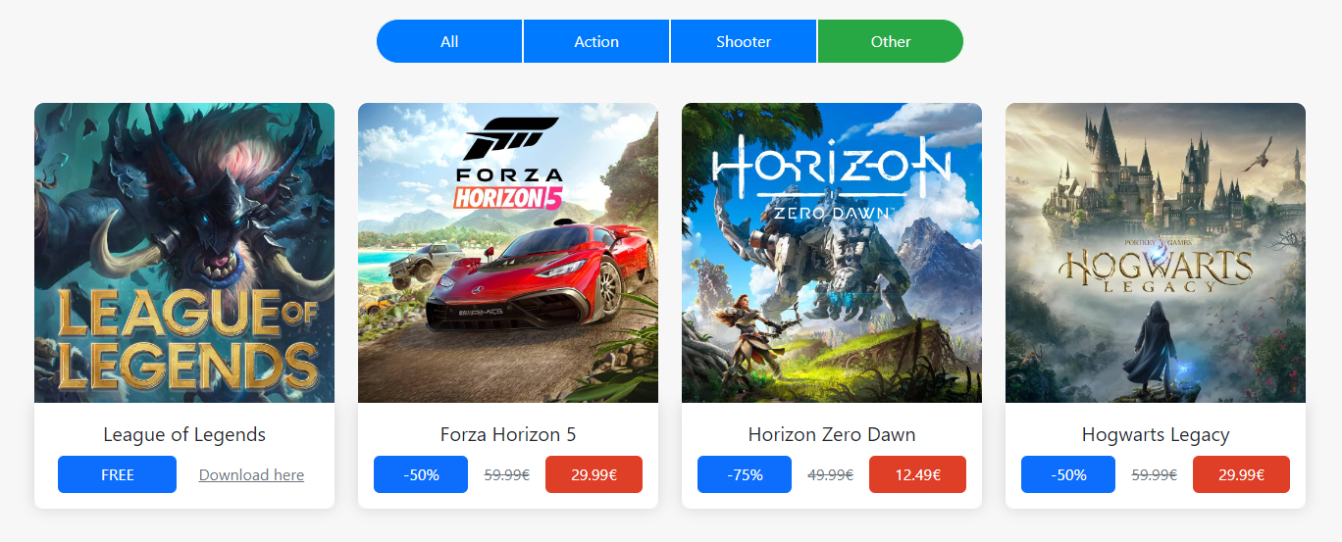

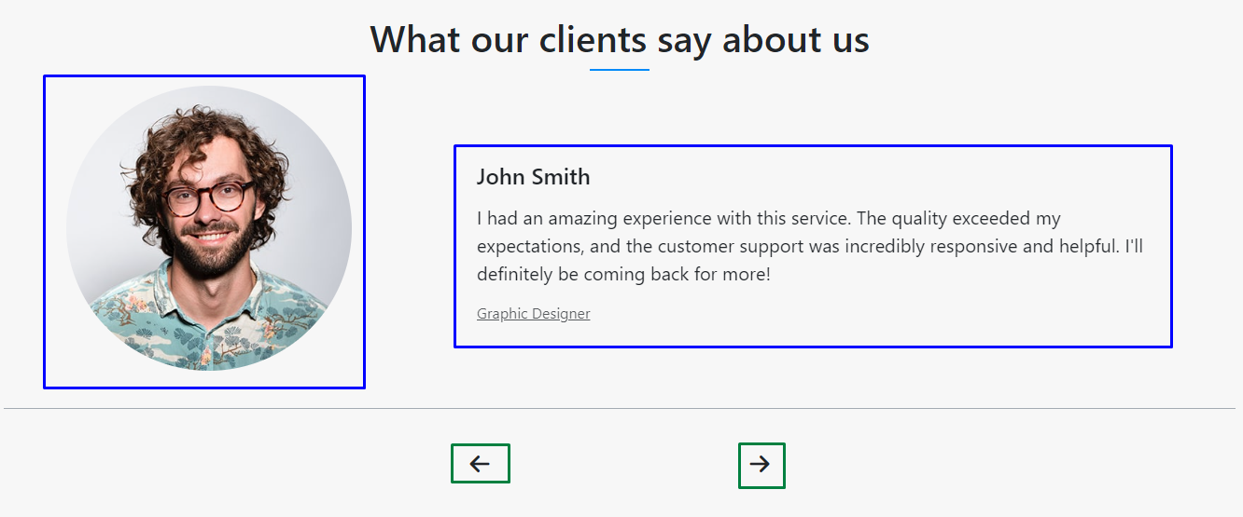

Dinamicki ispisan region za klijente koji se menjaju klikom na strelice (radjeno iz pomocu owlCarousel jQuery biblioteke)

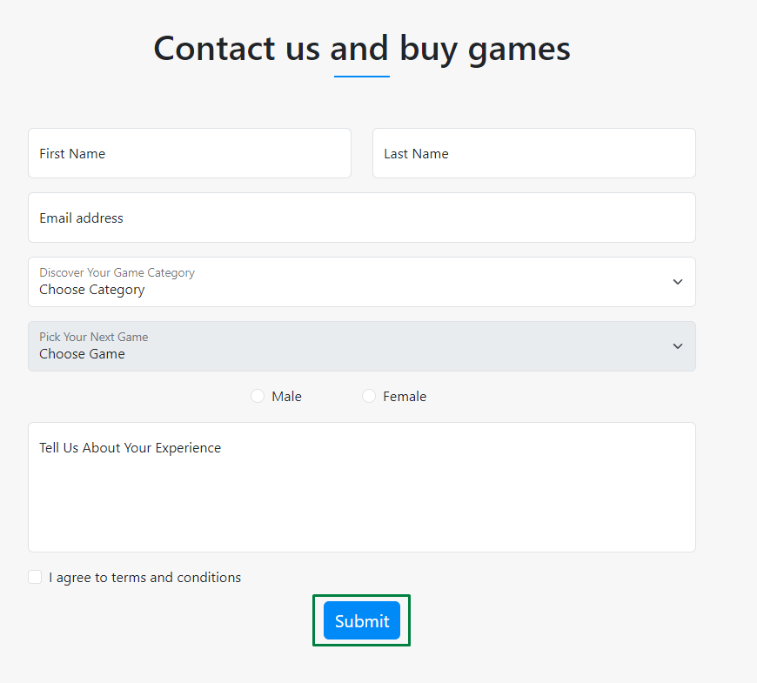

Klikom na submit se vrsi validacija u forme

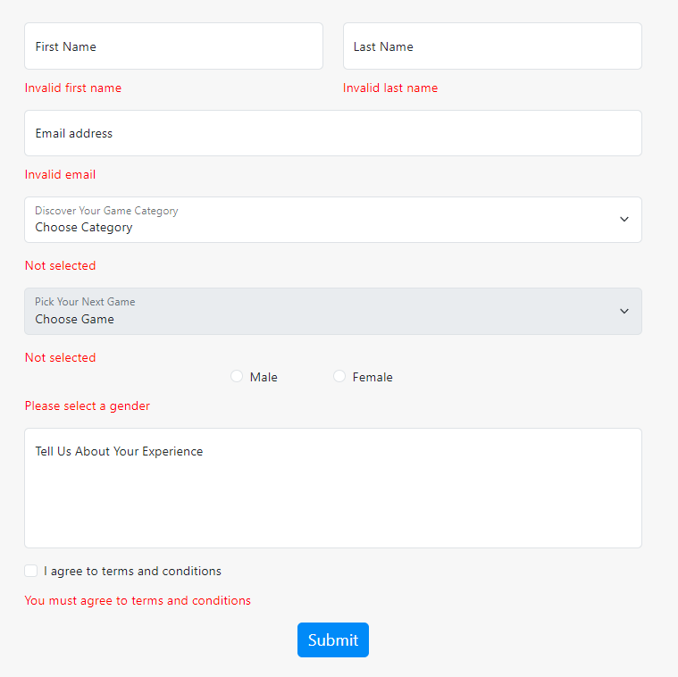

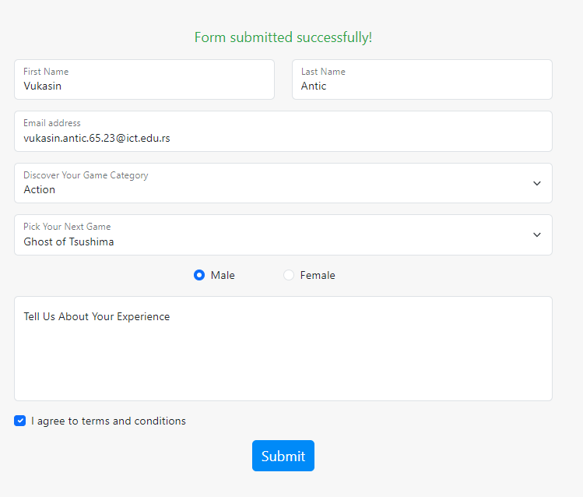

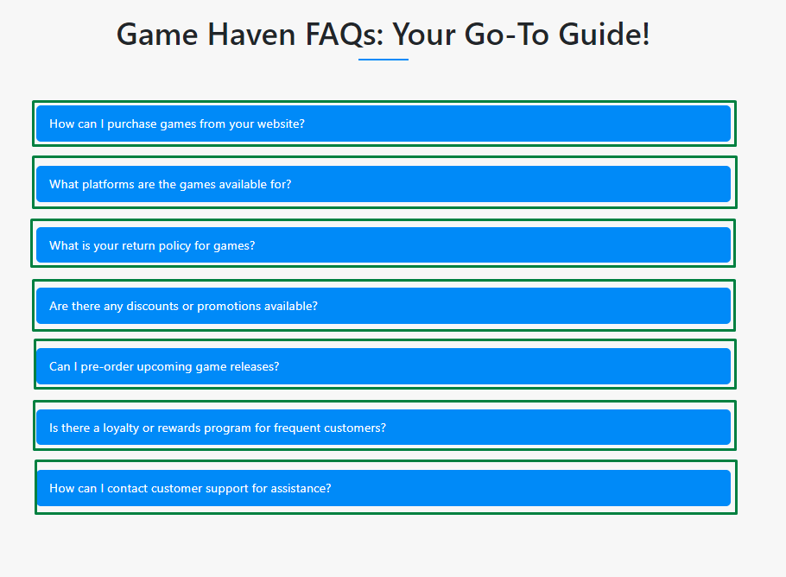

Dinamicki ispisan region FAQ gde se klikom na pitanje desava metod toggle koji je napisan uz pomoc jQuery-a

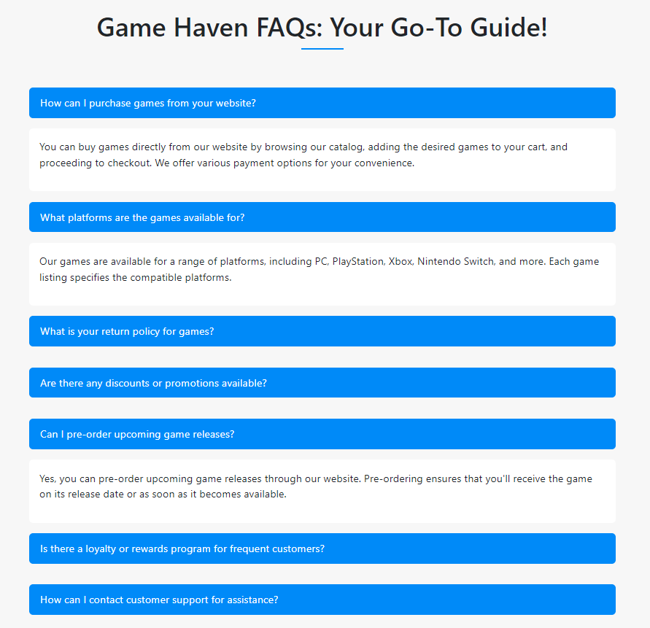

Odgovori su takodje ispisani dinamicki

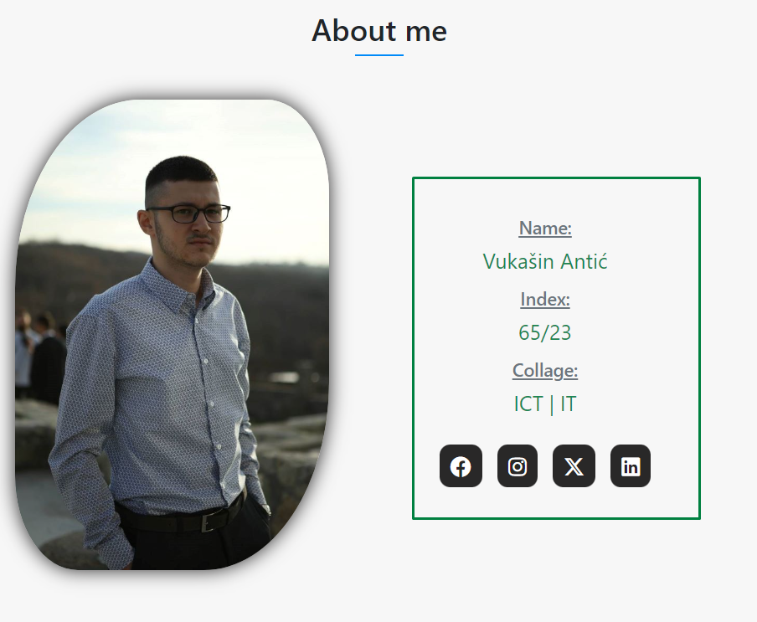

Dinamicki su ispisani podaci o autoru i lista ikonica sa linkovima

# Kodovi HTML

## Index.html

<!DOCTYPE html>

<html lang="en">

<head>

   <meta charset="UTF-8"/>

   <meta name="viewport" content="width=device-width, initial-scale=1.0"/>

   <meta name="description" content="Welcome to Game Haven! Explore our collection of discounted and latest games. Discover top-rated games, read reviews, and stay updated with the latest gaming news. Join our vibrant gaming community today!"/>

   <meta name="keywords" content="game haven, discounted games, latest games, top-rated games, game reviews, gaming news, vibrant gaming community"/>

   <meta author="Vukasin Antic"/>

   <title>Game Haven</title>

   <link rel="icon" type="image/png" href="assets/img/icon.png"/>

   <link rel="stylesheet" href="assets/css/style.css" type="text/css"/>

   <link href="https://cdn.jsdelivr.net/npm/bootstrap@5.3.3/dist/css/bootstrap.min.css" rel="stylesheet" integrity="sha384-QWTKZyjpPEjISv5WaRU9OFeRpok6YctnYmDr5pNlyT2bRjXh0JMhjY6hW+ALEwIH" crossorigin="anonymous">

   <link rel="stylesheet" href="https://cdnjs.cloudflare.com/ajax/libs/font-awesome/6.4.2/css/all.min.css" integrity="sha512-z3gLpd7yknf1YoNbCzqRKc4qyor8gaKU1qmn+CShxbuBusANI9QpRohGBreCFkKxLhei6S9CQXFEbbKuqLg0DA==" crossorigin="anonymous" referrerpolicy="no-referrer" />

   <!-- SLICK CSS ZA MAIN SLIDER! -->

   <link rel="stylesheet" type="text/css" href="https://cdnjs.cloudflare.com/ajax/libs/slick-carousel/1.8.1/slick.min.css"/>

   <link rel="stylesheet" type="text/css" href="https://cdnjs.cloudflare.com/ajax/libs/slick-carousel/1.8.1/slick-theme.min.css"/>

   </head>

<body>

   <!-- HEADER SECTION -->

   <header>

      <nav class="navbar navbar-expand-lg p-1 m-auto fixed-top">

         <div class="container-fluid fs-4">

            <a class="navbar-brand me-0 px-5 fs-4 text-uppercase" href="index.html">Game Haven</a>

            <div class="collapse navbar-collapse justify-content-end px-5" id="navbarNavDropdown">

            </div>

            <i class="fa fa-bars mobile-nav-toggle"></i>

         </div>

     </nav>

      <!-- SLIDER SECTION -->

      <div id="carouselExampleCaptions">

         <div class="carousel-inner">

         </div>

      </div>

   </header>

   <!-- SERVICES SECTION -->

   <section id="services">

   </section>

   <section id="about-us">

      <div id="secAbout" class="container py-3">

         <div class="container-fluid ">

            <div class="row mb-5">

               <div class="col-12 mx-auto text-center naslov">

                  <h1 class="display-2 fw-normal">About Us</h1>

               </div>

            </div>

            <div class="row g-5 align-items-center">

               <div class="d-none d-lg-block col-xl-3 col-lg-4">

                  <img class="img-fluid rounded" src="assets/img/gaming-zone.jpeg" alt="gaming-zone"/>

               </div>

               <div class="col-xl-5 col-lg-4 col-md-7">

                  <h1 class="display-1 text-primary mb-0 text-center">25</h1>

                  <p class="text-primary mb-4 text-center">Years of Experience</p>

                  <h1 class="display-5 mb-4 text-center">Your Ultimate Gaming Destination</h1>

                  <p class="mb-4">At Game Haven, we specialize in providing gamers with the best titles and deals in the industry. Our mission is to transform your gaming experience into an exciting adventure with premium games at unbeatable prices.

                  </p>

               </div>

               <div class="col-xl-4 col-lg-4 col-md-5">

                  <div class="row g-5">

                     <div class="col-12 col-lg-12">

                        <div class="border-start ps-4">

                           <i class="fa fa-award fa-3x text-primary mb3"></i>

                           <h4 class="mb-3">Award Winning</h4>

                           <span>Discover the difference of our trusted, customer-focused approach.</span>

                        </div>

                     </div>

                     <div class="col-12 col-lg-12">

                        <div class="border-start ps-4">

                           <i class="fa fa-users fa-3x text-primary mb3"></i>

                           <h4 class="mb-3">Dedicated Team</h4>

                           <span>Dedicated to delivering the best gaming experiences with a curated selection of top-tier titles and exclusive offers.</span>

                        </div>

                     </div>

                  </div>

               </div>

            </div>

         </div>

      </div>

   </section>

   <!-- FACTS SECTION -->

   <section id="facts">

       <div class="container-fluid facts my-5 py-5">

          <div class="container py-5" >

            <div class="row" id="facts-content">

            </div>

         </div>

       </div>

   </section>

   <!-- TRENDING GAMES SECTION -->

   <section id="trending" class="my-5 mx-auto">

   </section>

   <!-- LATEST GAMES SECTION -->

   <section id="latest-games">

   </section>

   <!-- MODALI -->

   <section id="modali">

   </section>

   <!-- FOOTER  -->

    <footer class="mt-5">

        <div class="container py-5">

            <div class="row flex-row-reverse latest-games-content">

                <div class="col-md-8 col-lg-4 mx-auto pb-4 align-self-center">

                    <h2 class="text-center">Newsletter</h2>

                    <div class="mt-3">

                       <form id="newsletter-form">

                        <div class="input-group">

                          <input type="email" class="form-control" id="emailFooter" aria-describedby="emailHelp" placeholder="Enter your email">

                          <button type="button" class="btn btn-primary" id="btn-submit-email">Subscribe</button>

                        </div>

                        </form>

                    </div>

                    <div id="message" class="pt-2 text-center"></div>

                </div>

            </div>

            <div class="row mt-5">

                <div class="col-12 text-center social-icon" id="si">

                </div>

            </div>

        </div>

        <div class="container-fluid footer-cr">

            <div class="row">

                <div class="col-12 text-center p-3">

                    <p class="m-0 fs-5">Copyright © 2024 Vukašin Antić 65/23. All Rights Reserved</p>

                </div>

            </div>

        </div>

    </footer>

   <!-- JQUERY -->

   <script src="https://code.jquery.com/jquery-3.6.0.min.js"></script>

   <!-- JQUERY ZA Owl Carousel -->

   <script src="https://code.jquery.com/jquery-3.6.0.min.js"></script>

   <!-- Owl Carousel JS -->

   <script src="https://cdnjs.cloudflare.com/ajax/libs/OwlCarousel2/2.3.4/owl.carousel.min.js"></script>

   <!-- SLICK JS ZA MAIN SLIDER! -->

   <script src="https://cdnjs.cloudflare.com/ajax/libs/slick-carousel/1.8.1/slick.min.js"></script>

   <!-- imagesloaded LB -->

   <script src="https://cdnjs.cloudflare.com/ajax/libs/jquery.imagesloaded/4.1.4/imagesloaded.pkgd.min.js"></script>

   <!-- isotope LB -->

   <script src="https://unpkg.com/isotope-layout@3/dist/isotope.pkgd.min.js"></script>

   <!-- main JS -->

   <script src="assets/js/main.js" type="text/javascript"></script>

</body>

</html>

## shop.html

<!DOCTYPE html>

<html lang="en">

<head>

    <meta charset="UTF-8"/>

    <meta name="viewport" content="width=device-width, initial-scale=1.0"/>

    <meta name="description" content="Explore the world of gaming at Game Haven's shop! Discover a wide range of action, adventure, shooter, and multiplayer games. From popular titles like Fortnite and PUBG to classics like GTA V and Red Dead Redemption 2, find your next gaming adventure here."/>

    <meta name="keywords" content="Game Haven, Shop, Games, Action, Adventure, Shooter, Multiplayer, Gaming, Download Games, Buy Games"/>

    <meta author="Vukasin Antic"/>

    <title>Game Haven</title>

    <link rel="icon" type="image/png" href="assets/img/icon.png"/>

    <link rel="stylesheet" href="assets/css/style.css" type="text/css"/>

    <link href="https://cdn.jsdelivr.net/npm/bootstrap@5.3.3/dist/css/bootstrap.min.css" rel="stylesheet" integrity="sha384-QWTKZyjpPEjISv5WaRU9OFeRpok6YctnYmDr5pNlyT2bRjXh0JMhjY6hW+ALEwIH" crossorigin="anonymous">

    <link rel="stylesheet" href="https://cdnjs.cloudflare.com/ajax/libs/font-awesome/6.4.2/css/all.min.css" integrity="sha512-z3gLpd7yknf1YoNbCzqRKc4qyor8gaKU1qmn+CShxbuBusANI9QpRohGBreCFkKxLhei6S9CQXFEbbKuqLg0DA==" crossorigin="anonymous" referrerpolicy="no-referrer" />

    <!-- Owl Carousel CSS -->

    <link rel="stylesheet" href="https://cdnjs.cloudflare.com/ajax/libs/OwlCarousel2/2.3.4/assets/owl.carousel.min.css">

    <link rel="stylesheet" href="https://cdnjs.cloudflare.com/ajax/libs/OwlCarousel2/2.3.4/assets/owl.theme.default.min.css">

</head>

<body>

    <!-- HEADER SECTION -->

    <header>

        <nav class="navbar navbar-expand-lg p-1 m-auto fixed-top">

           <div class="container-fluid fs-4">

              <a class="navbar-brand me-0 px-5 fs-4 text-uppercase" href="index.html">Game Haven</a>

              <div class="collapse navbar-collapse justify-content-end px-5" id="navbarNavDropdown">

              </div>

              <i class="fa fa-bars mobile-nav-toggle"></i>

           </div>

       </nav>

       <div class="container-fluid games-shop">

            <div class="row">

                <div class="col-12 text-center shop-naslov">

                    <h1 class="text-uppercase text-info">shop</h1>

                    <h4 class="fw-normal pt-2">

                        <a href="index.html" class="text-decoration-none">Home </a><i class="fas fa-angle-double-right"></i> Shop

                    </h4>

                </div>

            </div>

        </div>

    </header>

    <!-- SHOP -->

    <section id="shop">

        <div id="shopContainer" class="container pt-5">

            <div class="row">

                <div class="col-12 text-center">

                    <div class="mx-auto text-center naslov m-3">

                        <h1>Games</h1>

                    </div>

                </div>

            </div>

            <div id="filter-buttons" class="d-flex justify-content-center">

                <button class="filter-btn active" data-filter="*">All</button>

                <button class="filter-btn" data-filter=".Action">Action</button>

                <button class="filter-btn" data-filter=".Shooter">Shooter</button>

                <button class="filter-btn" data-filter=".Other">Other</button>

            </div>

        </div>

    </section>

    <!-- CLIENTS -->

    <section id="clients">

        <div id="shopContainer" class="container pt-5">

            <div class="row">

                <div class="col-12 text-center">

                    <div class="mx-auto text-center naslov m-3">

                        <h1>What our clients say about us</h1>

                    </div>

                </div>

            </div>

        </div>

        <div class="owl-carousel" id="client-carousel">

        </div>

    </section>

    <!-- FOOTER  -->

    <footer class="mt-5">

        <div class="container py-5">

            <div class="row flex-row-reverse latest-games-content">

                <div class="col-md-8 col-lg-4 mx-auto pb-4 align-self-center">

                    <h2 class="text-center">Newsletter</h2>

                    <div class="mt-3">

                       <form id="newsletter-form">

                        <div class="input-group">

                          <input type="email" class="form-control" id="emailFooter" aria-describedby="emailHelp" placeholder="Enter your email">

                          <button type="button" class="btn btn-primary" id="btn-submit-email">Subscribe</button>

                        </div>

                        </form>

                    </div>

                    <div id="message" class="pt-2 text-center"></div>

                </div>

            </div>

            <div class="row mt-5">

                <div class="col-12 text-center social-icon" id="si">

                </div>

            </div>

        </div>

        <div class="container-fluid footer-cr">

            <div class="row">

                <div class="col-12 text-center p-3">

                    <p class="m-0 fs-5">Copyright © 2024 Vukašin Antić 65/23. All Rights Reserved</p>

                </div>

            </div>

        </div>

    </footer>

    <!-- JQUERY -->

    <script src="https://code.jquery.com/jquery-3.6.0.min.js"></script>

    <!-- JQUERY ZA Owl Carousel -->

    <script src="https://code.jquery.com/jquery-3.6.0.min.js"></script>

    <!-- Owl Carousel JS -->

    <script src="https://cdnjs.cloudflare.com/ajax/libs/OwlCarousel2/2.3.4/owl.carousel.min.js"></script>

    <!-- SLICK JS ZA MAIN SLIDER! -->

    <script src="https://cdnjs.cloudflare.com/ajax/libs/slick-carousel/1.8.1/slick.min.js"></script>

    <!-- imagesloaded LB -->

    <script src="https://cdnjs.cloudflare.com/ajax/libs/jquery.imagesloaded/4.1.4/imagesloaded.pkgd.min.js"></script>

    <!-- isotope LB -->

    <script src="https://unpkg.com/isotope-layout@3/dist/isotope.pkgd.min.js"></script>

    <!-- main JS -->

    <script src="assets/js/main.js" type="text/javascript"></script>

</body>

</html>

## contact-us.html

<!DOCTYPE html>

<html lang="en">

<head>

    <meta charset="UTF-8"/>

    <meta name="viewport" content="width=device-width, initial-scale=1.0">

    <meta name="description" content="Contact Game Haven to buy your favorite games, ask questions, and learn about our services. Discover FAQs, promotions, and customer support information.">

    <meta name="keywords" content="Game Haven, contact Game Haven, buy games, game store, FAQs, gaming promotions, customer support, video games, PC games, PlayStation, Xbox, Nintendo Switch">

    <meta author="Vukasin Antic"/>

    <title>Game Haven</title>

    <link rel="icon" type="image/png" href="assets/img/icon.png"/>

    <link rel="stylesheet" href="assets/css/style.css" type="text/css"/>

    <link href="https://cdn.jsdelivr.net/npm/bootstrap@5.3.3/dist/css/bootstrap.min.css" rel="stylesheet" integrity="sha384-QWTKZyjpPEjISv5WaRU9OFeRpok6YctnYmDr5pNlyT2bRjXh0JMhjY6hW+ALEwIH" crossorigin="anonymous">

    <link rel="stylesheet" href="https://cdnjs.cloudflare.com/ajax/libs/font-awesome/6.4.2/css/all.min.css" integrity="sha512-z3gLpd7yknf1YoNbCzqRKc4qyor8gaKU1qmn+CShxbuBusANI9QpRohGBreCFkKxLhei6S9CQXFEbbKuqLg0DA==" crossorigin="anonymous" referrerpolicy="no-referrer" />

</head>

<body>

    <!-- HEADER SECTION -->

    <header>

        <nav class="navbar navbar-expand-lg p-1 m-auto fixed-top">

           <div class="container-fluid fs-4">

              <a class="navbar-brand me-0 px-5 fs-4 text-uppercase" href="index.html">Game Haven</a>

              <div class="collapse navbar-collapse justify-content-end px-5" id="navbarNavDropdown">

              </div>

              <i class="fa fa-bars mobile-nav-toggle"></i>

           </div>

       </nav>

       <div class="container-fluid about-us">

        <div class="row">

            <div class="col-12 text-center shop-naslov">

                <h1 class="text-uppercase text-info">contact us</h1>

                <h4 class="fw-normal pt-2">

                    <a href="index.html" class="text-decoration-none">Home </a><i class="fas fa-angle-double-right"></i> Contact us

                </h4>

            </div>

        </div>

    </div>

    </header>

    <section id="contact">

        <div class="container pb-3 mt-5">

            <div class="mx-auto text-center naslov">

                <h1>Contact us and buy games</h1>

            </div>

            <div class="container-fluid">

                <div class="row pb-5">

                    <div class="col-lg-8 mx-auto p-1 p-sm-5 form">

                        <form method="get">

                            <div class="row justify-content-center">

                                <div class="col-12">

                                    <div class="text-center" id="successMessage"></div>

                                </div>

                            </div>

                            <div class="row">

                                <div class="col-md-6 mb-3">

                                    <div class="form-floating">

                                        <input type="text" id="Fname" class="form-control" placeholder="First Name">

                                        <label for="Fname">First Name</label>

                                        <span class="formaEror" id="errorFname"></span>

                                    </div>

                                </div>

                                <div class="col-md-6 mb-3">

                                    <div class="form-floating">

                                        <input type="text" id="Lname" class="form-control" placeholder="Last Name">

                                        <label for="Lname">Last Name</label>

                                        <span class="formaEror" id="errorLname"></span>

                                    </div>

                                </div>

                            </div>

                            <div class="form-floating mb-3">

                                <input type="email" id="email" class="form-control" placeholder="">

                                <label for="email">Email address</label>

                                <span class="formaEror" id="errorEmail"></span>

                            </div>

                            <div class="form-floating mb-3" id="ddl-category">

                            </div>

                            <span id="errorDdl"></span>

                            <div class="form-floating my-3" id="ddl-games">

                            </div>

                            <span id="errorDdl-games"></span>

                            <div class="form-floating d-flex justify-content-center">

                                <div class="col-2 form-check">

                                    <input type="radio" name="gender" id="m" value="m" class="form-check-input" >

                                    <label class="form-check-label" for="m">Male</label>

                                </div>

                                <div class="col-2 form-check">

                                    <input type="radio" name="gender" id="f" value="f" class="form-check-input">

                                    <label class="form-check-label" for="f">Female</label>

                                </div>

                            </div>

                            <span class="formaEror" id="errorRb"></span>

                            <div class="form-floating my-3">

                                <textarea class="form-control" placeholder="Leave a comment here" id="floatingTextarea"></textarea>

                                <label for="floatingTextarea">Tell Us About Your Experience</label>

                            </div>

                            <div class="form-check">

                                <input type="checkbox" id="chb" class="form-check-input" >

                                <label class="form-check-label" for="chb">I agree to terms and conditions</label>

                            </div>

                            <span class="formaEror" id="errorChb"></span>

                        </form>

                        <div class="col-12 d-flex justify-content-center mt-3">

                            <button class="btn btn-send text-white fs-5" type="submit" id="btn-submit">Submit</button>

                        </div>

                    </div>

                </div>

            </div>

    </section>

    <!-- QUESTIONS -->

    <section id="questions">

        <div class="container">

            <div class="mx-auto text-center naslov">

                <h1>Game Haven FAQs: Your Go-To Guide!</h1>

            </div>

            <div class="row p-sm-5 justify-content-center" id="faq-container">

            </div>

        </div>

    </section>

    <!-- FOOTER  -->

    <footer class="mt-5">

        <div class="container py-5">

            <div class="row flex-row-reverse latest-games-content">

                <div class="col-md-8 col-lg-4 mx-auto pb-4 align-self-center">

                    <h2 class="text-center">Newsletter</h2>

                    <div class="mt-3">

                       <form id="newsletter-form">

                        <div class="input-group">

                          <input type="email" class="form-control" id="emailFooter" aria-describedby="emailHelp" placeholder="Enter your email">

                          <button type="button" class="btn btn-primary" id="btn-submit-email">Subscribe</button>

                        </div>

                        </form>

                    </div>

                    <div id="message" class="pt-2 text-center"></div>

                </div>

            </div>

            <div class="row mt-5">

                <div class="col-12 text-center social-icon" id="si">

                </div>

            </div>

        </div>

        <div class="container-fluid footer-cr">

            <div class="row">

                <div class="col-12 text-center p-3">

                    <p class="m-0 fs-5">Copyright © 2024 Vukašin Antić 65/23. All Rights Reserved</p>

                </div>

            </div>

        </div>

    </footer>

    <!-- JQUERY -->

    <script src="https://code.jquery.com/jquery-3.6.0.min.js"></script>

    <!-- JQUERY ZA Owl Carousel -->

    <script src="https://code.jquery.com/jquery-3.6.0.min.js"></script>

    <!-- Owl Carousel JS -->

    <script src="https://cdnjs.cloudflare.com/ajax/libs/OwlCarousel2/2.3.4/owl.carousel.min.js"></script>

    <!-- SLICK JS ZA MAIN SLIDER! -->

    <script src="https://cdnjs.cloudflare.com/ajax/libs/slick-carousel/1.8.1/slick.min.js"></script>

    <!-- imagesloaded LB -->

    <script src="https://cdnjs.cloudflare.com/ajax/libs/jquery.imagesloaded/4.1.4/imagesloaded.pkgd.min.js"></script>

    <!-- isotope LB -->

    <script src="https://unpkg.com/isotope-layout@3/dist/isotope.pkgd.min.js"></script>

    <!-- main JS -->

    <script src="assets/js/main.js" type="text/javascript"></script>

    <script src="assets/js/contact.js" type=" text/javascript "></script>

</body>

</html>

## author.html

<!DOCTYPE html>

<html lang="en">

<head>

    <meta charset="UTF-8"/>

    <meta name="viewport" content="width=device-width, initial-scale=1.0"/>

    <meta name="description" content="Welcome to Game Haven! Discover more about Vukašin Antić, his background, and interests. Get insights into his academic journey, hobbies, and social media profiles. Connect with him and explore the world of gaming through his perspective."/>

    <meta name="keywords" content="Game Haven, Vukašin Antić, About Me, ICT, IT, Newsletter, Gaming Community, Vibrant Community, Endless Possibilities"/>

    <meta author="Vukasin Antic"/>

    <title>Game Haven</title>

    <link rel="icon" type="image/png" href="assets/img/icon.png"/>

    <link rel="stylesheet" href="assets/css/style.css" type="text/css"/>

    <link href="https://cdn.jsdelivr.net/npm/bootstrap@5.3.3/dist/css/bootstrap.min.css" rel="stylesheet" integrity="sha384-QWTKZyjpPEjISv5WaRU9OFeRpok6YctnYmDr5pNlyT2bRjXh0JMhjY6hW+ALEwIH" crossorigin="anonymous">

    <link rel="stylesheet" href="https://cdnjs.cloudflare.com/ajax/libs/font-awesome/6.4.2/css/all.min.css" integrity="sha512-z3gLpd7yknf1YoNbCzqRKc4qyor8gaKU1qmn+CShxbuBusANI9QpRohGBreCFkKxLhei6S9CQXFEbbKuqLg0DA==" crossorigin="anonymous" referrerpolicy="no-referrer" />

</head>

<body>

    <!-- HEADER SECTION -->

    <header>

        <nav class="navbar navbar-expand-lg p-1 m-auto fixed-top">

           <div class="container-fluid fs-4">

              <a class="navbar-brand me-0 px-5 fs-4 text-uppercase" href="index.html">Game Haven</a>

              <div class="collapse navbar-collapse justify-content-end px-5" id="navbarNavDropdown">

              </div>

              <i class="fa fa-bars mobile-nav-toggle"></i>

           </div>

       </nav>

       <div class="container-fluid about-us">

        <div class="row">

            <div class="col-12 text-center shop-naslov">

                <h1 class="text-uppercase text-info">about me</h1>

                <h4 class="fw-normal pt-2">

                    <a href="index.html" class="text-decoration-none">Home </a><i class="fas fa-angle-double-right"></i> Author

                </h4>

            </div>

        </div>

    </div>

    </header>

    <!-- ABOUT ME -->

    <section id="about-me">

        <div class="container">

            <div class="mx-auto text-center naslov py-5">

                <h1>About me</h1>

            </div>

            <div class="row justify-content-center align-items-center">

                <div class="col-lg-4 col-md-7 col-9 pb-5">

                    <img src="assets/img/autor.jpg" alt="author" class="img-fluid author-img mx-auto"/>

                </div>

                <div class="col-lg-5 text-center" id="authorInfo">

                </div>

            </div>

        </div>

    </section>

    <!-- FOOTER  -->

    <footer class="mt-5">

        <div class="container py-5">

            <div class="row flex-row-reverse latest-games-content">

                <div class="col-md-8 col-lg-4 mx-auto pb-4 align-self-center">

                    <h2 class="text-center">Newsletter</h2>

                    <div class="mt-3">

                       <form id="newsletter-form">

                        <div class="input-group">

                          <input type="email" class="form-control" id="emailFooter" aria-describedby="emailHelp" placeholder="Enter your email">

                          <button type="button" class="btn btn-primary" id="btn-submit-email">Subscribe</button>

                        </div>

                        </form>

                    </div>

                    <div id="message" class="pt-2 text-center"></div>

                </div>

            </div>

            <div class="row mt-5">

                <div class="col-12 text-center social-icon" id="si">

                </div>

            </div>

        </div>

        <div class="container-fluid footer-cr">

            <div class="row">

                <div class="col-12 text-center p-3">

                    <p class="m-0 fs-5">Copyright © 2024 Vukašin Antić 65/23. All Rights Reserved</p>

                </div>

            </div>

        </div>

    </footer>

    <!-- JQUERY -->

    <script src="https://code.jquery.com/jquery-3.6.0.min.js"></script>

    <!-- JQUERY ZA Owl Carousel -->

    <script src="https://code.jquery.com/jquery-3.6.0.min.js"></script>

    <!-- Owl Carousel JS -->

    <script src="https://cdnjs.cloudflare.com/ajax/libs/OwlCarousel2/2.3.4/owl.carousel.min.js"></script>

    <!-- SLICK JS ZA MAIN SLIDER! -->

    <script src="https://cdnjs.cloudflare.com/ajax/libs/slick-carousel/1.8.1/slick.min.js"></script>

    <!-- imagesloaded LB -->

    <script src="https://cdnjs.cloudflare.com/ajax/libs/jquery.imagesloaded/4.1.4/imagesloaded.pkgd.min.js"></script>

    <!-- isotope LB -->

    <script src="https://unpkg.com/isotope-layout@3/dist/isotope.pkgd.min.js"></script>

    <!-- main JS -->

    <script src="assets/js/main.js" type="text/javascript"></script>

</body>

</html>

# CSS

## Style.css

:root{

    --eldenring: #C18C3A;

    --rdr2: #f32929;

    --acv: #39C3AD;

}

*{

    margin: 0px;

    padding: 0px;

    scroll-behavior: smooth;

    box-sizing: border-box;

}

body{

    background-color: #f7f7f7 !important;

    font-family: "Segoe UI", sans-serif !important;

}

.bg-red{

    background-color: #e03f27 !important;

}

.text-red{

    color: #FF2400 !important;

}

.sale{

    border-radius: 6px;

    padding: 7px;

}

.line::after{

    content: "";

    height: 2px;

    background-color: #292828;

    display: block;

    margin: 10px auto;

}

.btn-price{

    width: 44%;

    text-align: center;

}

.shop-naslov h4, .shop-naslov a{

    color: #fff;

}

/* HEADER */

nav{

    background-color: rgba(255, 255, 255, 0.75);

}

ul li{

    list-style: none !important;

}

ul li a{

    color: #fff;

}

.mobile-nav-toggle {

    font-size: 2rem;

    color: #000;

    cursor: pointer;

}

/* NAV ZA MOBILNI* */

.navbar-mobile-menu {

    width: 100%;

    padding: 0.5rem;

    transition: height 0.3s ease-in-out;

    display: none;

}

.navbar-mobile ul li a{

    font-size: 20px;

}

.navbar-mobile .nav-link {

    padding: 0.75rem 1rem;

    margin-left: 40px;

}

/* SLIDER */

.carousel-items{

    background-position: center bottom;

    background-repeat: no-repeat;

    background-size: cover;

    position: relative;

    padding: 225px 0px;

}

.img1{

    background-image: linear-gradient(rgba(0, 0, 0, 0.1), rgba(0, 0, 0, 0.1)),url(../img/rdr2.jpg);

}

.img2{

    background-image: linear-gradient(rgba(0, 0, 0, 0.5), rgba(0, 0, 0, 0.5)),url(../img/elden-ring.jpg);

    background-position: left;

}

.img3{

    background-image: linear-gradient(rgba(0, 0, 0, 0.6), rgba(0, 0, 0, 0.6)),url(../img/assasin-creed-valhala.jpg);

    background-position: center;

}

.img3 img{

    filter: brightness(0.9);

}

.img3 img{

    filter: brightness(0.9);

}

.header-text{

    color: #fff;

}

.text-box{

    color: #000;

    background: rgba(255, 255, 255, 0.5);

    border-radius: 50px

}

.rdr2{

    color: var(--rdr2);

}

.rdr2-img img{

    filter: grayscale(60%);

}

.er{

    color: var(--eldenring);

}

.aw{

    color: var(--acv);

}

.header-img{

    position: relative;

}

.header-img img{

    border-radius: 20px;

}

.offer{

    position: absolute;

    left: 25px;

    bottom: 25px;

    font-size: 24px;

    color: #fff;

    border-radius: 6px;

    padding: 2px 16px 3px 16px;

}

.price{

    position: absolute;

    right: 25px;

    bottom: 25px;

    font-size: 24px;

    color: #fff;

    border-radius: 6px;

    padding: 2px 16px 3px 16px;

}

/* DOTS SLICK */

.slick-dots {

    bottom: 50px !important;

    left: 50%;

    transform: translateX(-50%);

    font-size: 320px;

}

.slick-dots li {

    margin: 0 25px !important;

}

.slick-dots li button:before {

    color: rgba(255, 255, 255, 0.9) !important;

    font-size: 30px !important;

}

.slick-dots li:nth-child(1).slick-active button:before{

    color: var(--rdr2) !important;

}

.slick-dots li:nth-child(2).slick-active button:before{

    color: var(--eldenring) !important;

}

.slick-dots li:nth-child(3).slick-active button:before{

    color: var(--acv) !important;

}

/* SERVICE */

#services{

    margin-top: -140px;

}

.service-box{

    box-shadow: 0px 0px 15px rgba(0, 0, 0, 0.15);

    border-radius: 25px !important;

}

#trending{

    width: 80%;

}

.card{

    border: none !important;

    border-radius: 10px 10px 0px 0px;

}

.card img{

    border-radius: 10px 10px 0px 0px;

}

.trending-box{

    box-shadow: 0px 0px 15px rgba(0, 0, 0, 0.15);

    border-radius: 0px 0px 10px 10px;

}

.naslov::after{

    content: "";

    height: 2px;

    width: 5%;

    background-color: #008af8;

    display: block;

    margin: 10px auto;

}

/* FACTS */

#facts{

    background-image: url(../img/facts.jpg);

    background-position: center;

    background-size: cover;

    background-attachment: fixed;

}

/* MODALI */

.custom-modal {

    display: none;

    position: fixed;

    top: 0;

    left: 0;

    width: 100%;

    height: 100%;

    background-color: rgba(0, 0, 0, 0.5);

    z-index: 1050;

    overflow: hidden;

}

.custom-modal-dialog {

    position: relative;

    margin: 0px auto;

    top: 14%;

    max-width: 600px;

    width: 90%;

    background: white;

    border-radius: 5px;

    overflow: hidden;

}

.custom-modal-header {

    border-bottom: 1px solid #ddd;

}

.custom-modal-footer {

    border-top: 1px solid #ddd;

}

.close-modal {

    background: none;

    border: none;

    font-size: 2rem;

    cursor: pointer;

}

.custom-modal img{

    width: 100%;

}

/* SECTION latest-games */

.latest-games-content::after, .cl-item::after{

    content: "";

    height: 1px;

    width: 100%;

    background-color: rgb(163, 171, 178);

    display: block;

    margin: 0px auto;

}

.latest-games-content img{

    border-radius: 30px;

}

.bg-b{

    background-color: #292828 !important;

}

/* FOOTER */

footer{

    background-color: #292828;

    color: #fff;

}

.social-icon ul li a{

    color: #292828;

}

.footer-cr{

    background-color: #008af8;

}

/* SHOP HTML */

.games-shop{

    background-image: linear-gradient(161deg, rgba(218, 218, 218, 0.03) 0%, rgba(218, 218, 218, 0.03) 21%,rgba(145, 145, 145, 0.03) 21%, rgba(145, 145, 145, 0.03) 49%,rgba(34, 34, 34, 0.03) 49%, rgba(34, 34, 34, 0.03) 58%,rgba(64, 64, 64, 0.03) 58%, rgba(64, 64, 64, 0.03) 68%,rgba(151, 151, 151, 0.03) 68%, rgba(151, 151, 151, 0.03) 78%,rgba(96, 96, 96, 0.03) 78%, rgba(96, 96, 96, 0.03) 85%,rgba(181, 181, 181, 0.03) 85%, rgba(181, 181, 181, 0.03) 100%),linear-gradient(101deg, rgba(71, 71, 71, 0.03) 0%, rgba(71, 71, 71, 0.03) 1%,rgba(233, 233, 233, 0.03) 1%, rgba(233, 233, 233, 0.03) 4%,rgba(139, 139, 139, 0.03) 4%, rgba(139, 139, 139, 0.03) 34%,rgba(177, 177, 177, 0.03) 34%, rgba(177, 177, 177, 0.03) 42%,rgba(130, 130, 130, 0.03) 42%, rgba(130, 130, 130, 0.03) 75%,rgba(38, 38, 38, 0.03) 75%, rgba(38, 38, 38, 0.03) 91%,rgba(216, 216, 216, 0.03) 91%, rgba(216, 216, 216, 0.03) 100%),linear-gradient(54deg, rgba(8, 8, 8, 0.03) 0%, rgba(8, 8, 8, 0.03) 25%,rgba(166, 166, 166, 0.03) 25%, rgba(166, 166, 166, 0.03) 39%,rgba(181, 181, 181, 0.03) 39%, rgba(181, 181, 181, 0.03) 41%,rgba(200, 200, 200, 0.03) 41%, rgba(200, 200, 200, 0.03) 74%,rgba(18, 18, 18, 0.03) 74%, rgba(18, 18, 18, 0.03) 83%,rgba(134, 134, 134, 0.03) 83%, rgba(134, 134, 134, 0.03) 86%,rgba(56, 56, 56, 0.03) 86%, rgba(56, 56, 56, 0.03) 100%),linear-gradient(264deg, rgba(209, 209, 209, 0.03) 0%, rgba(209, 209, 209, 0.03) 18%,rgba(31, 31, 31, 0.03) 18%, rgba(31, 31, 31, 0.03) 26%,rgba(77, 77, 77, 0.03) 26%, rgba(77, 77, 77, 0.03) 27%,rgba(3, 3, 3, 0.03) 27%, rgba(3, 3, 3, 0.03) 36%,rgba(125, 125, 125, 0.03) 36%, rgba(125, 125, 125, 0.03) 37%,rgba(233, 233, 233, 0.03) 37%, rgba(233, 233, 233, 0.03) 64%,rgba(118, 118, 118, 0.03) 64%, rgba(118, 118, 118, 0.03) 100%),linear-gradient(90deg, rgb(26, 26, 26),rgb(24, 24, 24));    width: 1920px;

    height: 600px;

    padding: 280px;

}

#shopContainer{

    height: auto !important;

}

#filter-buttons{

    margin: 20px 0;

}

.filter-btn {

    width: 150px;

    background-color: #007bff;

    color: white;

    border: none;

    padding: 10px 0px;

    border: 1px solid #f7f7f7;

    cursor: pointer;

    transition: background-color 0.3s ease;

    text-align: center;

}

.filter-btn:first-child{

    border-radius: 50px 0px 0px 50px;

}

.filter-btn:last-child{

    border-radius: 0px 50px 50px 0px;

}

.filter-btn:hover {

    background-color:  #0056b3;

}

.filter-btn.active {

    background-color: #28a745;

}

.shop-item {

    position: relative !important;

    left: 0 !important;

    top: 0 !important;

    opacity: 1;

    transform: scale(1) !important;

    transition: opacity 0.7s ease-in-out, transform 0.7s ease-in-out;

}

button{

    border: none;

}

.shop-item.is-hidden, .shop-item.isotope-hidden {

    opacity: 0;

    transform: scale(0.9);

    pointer-events: none;

}

/* KLIJENTI */

.client-carousel .client-item {

    margin-bottom: -2rem;

}

.cl-item::after{

    content: "";

    height: 1px;

    width: 100%;

    background-color: rgb(163, 171, 178);

    display: block;

    margin: 40px auto;

}

.owl-nav{

    display: flex;

    justify-content: center;

}

.owl-prev, .owl-next{

    margin: 0px 100px !important;

    font-size: 24px !important;

    transition: 0.5s all !important;

    width: 100px;

}

.owl-prev:hover, .owl-next:hover{

    color: #292828 !important;

    background-color: #f7f7f7 !important;

}

.form-floating textarea{

    height: 150px !important;

    resize: none;

}

.formaEror{

    padding: 10px 0px 0px 0px;

}

.btn-send{

    background-color: #008af8 !important;

    border: 1px solid #008af8 !important;

    transition: .5s ease-in-out all !important;

}

.btn-send:hover{

    background-color: #f7f7f7 !important;

    color: #008af8 !important;

}

.btn-question{

    /* background-color: #292828 !important; */

    color: #fff !important;

    width: 100%;

}

/* ABOUT ME */

.about-us{

    background-image: linear-gradient(17deg, rgba(41, 41, 41, 0.02) 0%, rgba(41, 41, 41, 0.02) 48%,rgba(10, 10, 10, 0.02) 48%, rgba(10, 10, 10, 0.02) 59%,rgba(164, 164, 164, 0.02) 59%, rgba(164, 164, 164, 0.02) 73%,rgba(79, 79, 79, 0.02) 73%, rgba(79, 79, 79, 0.02) 93%,rgba(42, 42, 42, 0.02) 93%, rgba(42, 42, 42, 0.02) 100%),linear-gradient(42deg, rgba(124, 124, 124, 0.02) 0%, rgba(124, 124, 124, 0.02) 15%,rgba(116, 116, 116, 0.02) 15%, rgba(116, 116, 116, 0.02) 23%,rgba(41, 41, 41, 0.02) 23%, rgba(41, 41, 41, 0.02) 44%,rgba(196, 196, 196, 0.02) 44%, rgba(196, 196, 196, 0.02) 54%,rgba(145, 145, 145, 0.02) 54%, rgba(145, 145, 145, 0.02) 100%),linear-gradient(151deg, rgba(85, 85, 85, 0.02) 0%, rgba(85, 85, 85, 0.02) 12%,rgba(72, 72, 72, 0.02) 12%, rgba(72, 72, 72, 0.02) 28%,rgba(156, 156, 156, 0.02) 28%, rgba(156, 156, 156, 0.02) 33%,rgba(230, 230, 230, 0.02) 33%, rgba(230, 230, 230, 0.02) 50%,rgba(13, 13, 13, 0.02) 50%, rgba(13, 13, 13, 0.02) 100%),linear-gradient(76deg, rgba(25, 25, 25, 0.02) 0%, rgba(25, 25, 25, 0.02) 9%,rgba(183, 183, 183, 0.02) 9%, rgba(183, 183, 183, 0.02) 32%,rgba(19, 19, 19, 0.02) 32%, rgba(19, 19, 19, 0.02) 86%,rgba(129, 129, 129, 0.02) 86%, rgba(129, 129, 129, 0.02) 88%,rgba(174, 174, 174, 0.02) 88%, rgba(174, 174, 174, 0.02) 100%),linear-gradient(90deg, rgb(41, 41, 41),rgb(8, 8, 8));    position: relative;

    height: 600px;

    padding: 280px;

}

.author-img{

    border-radius: 40% 20% 40% 20%;

    box-shadow: 0px 0px 25px #292828;

}

.author .list-item{

    border: none !important;

    border-width: 0px !important;

    background-color: transparent;

    padding: 10px;

}

.author .list-item a{

    color: #fff;

    background-color: #292828;

    padding: 10px 14.5px;

    border-radius: 25%;

    transition: 0.5s all;

}

.author .list-item a:hover{

    color: #292828;

    background-color: #f7f7f7;

}

/* RESPONSIVE CSS */

@media (max-width: 1390px) {

    .sale{

        width: 43% !important;

    }

    .btn-price {

        width: auto;

    }

}

@media (max-width: 1199px) {

    .btn-price {

        width: 49% !important;

    }

}

@media (max-width: 991px) {

    .mobile-nav-toggle {

        display: block;

    }

    .navbar-mobile-menu {

        display: flex;

    }

    .carousel-items{

        padding: 300px 0px;

    }

    .filter-btn {

        width: 100px;

    }

}

@media (min-width: 992px) {

    .mobile-nav-toggle {

        display: none !important;

    }

}

@media (max-width: 767px){

    .filter-btn {

        width: 90px;

    }

}

# JavaScript

## Main.js

// INDEX.HTML

window.addEventListener('load', function(){

    generateMenu();

    generateService();

    generateLatestGames();

    generateAuthorInfo();

})

// MENI

const menu = [

    {

        text : "Home",

        link : "index.html",

    },

    {

        text : "Shop",

        link : "shop.html"

    },

    {

        text : "Contact Us",

        link : "contact-us.html"

    },

    {

        text : "Author",

        link : "author.html"

    }

];

function generateMenu() {

    var navbar = document.querySelector('#navbarNavDropdown');

    const currentURL = window.location.href;

    let ul = document.createElement('ul');

    ul.setAttribute('class', 'navbar-nav fw-normal');

    menu.forEach(function (item) {

        let li = document.createElement('li');

        let a = document.createElement('a');

        a.setAttribute('href', item.link);

        a.setAttribute('class', 'nav-link');

        a.textContent = item.text;

        if (currentURL.includes(item.link)) {

            a.classList.add('active');

        }

        li.appendChild(a);

        ul.appendChild(li);

    });

    navbar.appendChild(ul);

}

// SLIDER

const carouselItems = [

    {   bgImg: 'img1',

        colorTitle: 'rdr2',

        title: 'Red Dead Redemption 2',

        text: ' stands as a gaming masterpiece, blending an immersive open world with a compelling narrative. Its rich storytelling, intricate character development, stunning visuals, and attention to detail elevate it, offering players an unparalleled and unforgettable Wild West experience.',

        img: 'rdr2-logo-cover',

        alt: 'rdr2',

        imgKlasa: 'rdr2-img',

        sale: '67',

        price: '19.79'

    },

    {   bgImg: 'img2',

        colorTitle: 'er',

        title: 'Elden Ring',

        text: ', a collaborative masterpiece between Hidetaka Miyazaki and George R.R. Martin, unfolds a dark and mysterious fantasy world. Renowned for its challenging gameplay, intricate lore, and breathtaking landscapes, Elden Ring captivates players with its unparalleled depth and innovation in the action RPG genre.',

        img: 'elden-ring-logo',

        alt: 'elden-ring',

        imgKlasa: '',

        sale: '50',

        price: '29.99'

    },

    {   bgImg: 'img3',

        colorTitle: 'aw',

        title: "Assassin's Creed Valhalla",

        text: ' offers a Viking odyssey, seamlessly blending history with mythic elements. With stunning visuals, robust storytelling, and vast open-world exploration, Valhalla delivers an immersive experience, combining stealth, combat, and strategic choices for an epic adventure in Norse mythology.',

        img: 'assasin-creed-valhala-logo',

        alt: 'assasin-creed-valhala',

        imgKlasa: '',

        sale: '75',

        price: '14.99'

    }

];

function autoSlider(){

    var carousel = document.querySelector(".carousel-inner");

    if(carousel){

    let htmlSlider=``;

    carouselItems.forEach(function(item){

        htmlSlider += `<div class="carousel-items ${item.bgImg}">

            <div class="container main-games">

               <div class="row justify-content-center">

                  <div class="col-lg-7 align-self-center pb-2 ">

                     <div class="caption header-text  p-4">

                        <h2 >Welcome to Game Haven</h2>

                        <h3>Today's offer: <span class="fw-bold text-uppercase ${item.colorTitle}">${item.title}</span></h3>

                        <p class="fs-5"><span class="fs-3">${item.title}</span>${item.text}

                        </p>

                     </div>

                  </div>

                  <div class="col-lg-4 col-11 offset-lg-1 pt-2">

                     <div class="header-img ${item.imgKlasa}">

                        <img class="img-fluid" src="assets/img/${item.img}.jpg" alt="${item.alt}"/>

                        <span class="offer bg-red">${item.sale}&#37;</span>

                        <span class="price bg-primary">${item.price}&#8364;</span>

                     </div>

                  </div>

               </div>

            </div>

         </div>`

    })

    carousel.innerHTML=htmlSlider;

    }

}

// SERVICE

const serviceItems = [

    {

        title: 'Game Sale',

        icon: 'fa-tags',

        color: 'danger',

        text: 'Explore our discounted game collection!'

    },

    {

        title: 'New Releases',

        icon: 'fa-gamepad',

        color: 'success',

        text: 'Discover the latest and greatest games.'

    },

    {

        title: 'Featured Games',

        icon: 'fa-star',

        color: 'warning',

        text: 'Discover top-rated and thrilling games.'

    },

    {

        title: 'Game Reviews',

        icon: 'fa-comment',

        color: 'primary',

        text: 'Explore our reviews, find top-rated picks.'

    }

];

function generateService(){

    var service = document.querySelector('#services');

    if (service){

        let htmlService = `<div class="container mt-5">

            <div class="row">`;

        serviceItems.forEach(function(item){

            htmlService += `<div class="col-lg-3 col-md-6 mb-4">

                    <div class="card service-box">

                        <div class="card-body text-center">

                            <h5 class="card-title">${item.title}</h5>

                            <i class="fas fa-3x p-1 ${item.icon} text-${item.color}"></i>

                            <p class="card-text pt-3">${item.text}</p>

                        </div>

                    </div>

                </div>`;

        })

        htmlService += `</div></div>`;

        service.innerHTML = htmlService;

    }

}

// FACTS

const factsItems = [

    {

        number: '5321',

        text: 'Satisfied Gamers',

    },

    {

        number: '1475',

        text: 'Games Sold'

    },

    {

        number: '310',

        text: 'Games in Library'

    },

    {

        number: '80',

        text: 'Exclusive Discounts'

    }

];

var divFacts = document.querySelector('#facts-content');

if(divFacts){

    function createFact(item){

        let fact = `<div class="col-sm-6 col-lg-3 text-center my-3">

                        <h1 class="display-4 text-white custom-counter">${item.number}</h1>

                        <span class="fs-5 fw-semi-bold aw">${item.text}</span>

                    </div>`

        return fact;

    };

    for(let item of factsItems){

        divFacts.innerHTML += createFact(item)

    }

}

// FACTS COUNTER

function counterUp(elem, duration, delay){

    var animationStarted = false;

    var value = parseFloat(elem.innerText);

    var starter = 0;

    var steps = duration / delay;

    var step = value / steps;

    elem.innerText = starter;

    function startAnimate(){

        var intId = setInterval(function(){

            if(starter >= value){

            starter = value;

            clearInterval(intId);

        }

        elem.innerText = starter.toFixed(0);

        starter += step;

    }, delay)

}

    document.addEventListener("scroll", function(){

        // var windowHeight = window.innerHeight;

        var scrollTop = elem.getBoundingClientRect().top;

        if(scrollTop < 800 && !animationStarted){

            startAnimate();

            animationStarted = true;

        }

    })

}

var elements = document.querySelectorAll(".custom-counter");

elements.forEach(function(el){

    counterUp(el, 4000, 10);

})

// TRENDING GAMES SECTION

const gameItems = [

    {

        img: 'assassins-creed-mirage',

        alt: 'assassins-creed-mirage',

        title: `Assassin's Creed Mirage`,

        price: '39.99&#8364;',

        id: '1'

    },

    {

        img: 'cs2',

        alt: 'cs2',

        title: `Counter-Strike 2`,

        price: 'FREE',

        id: '2'

    },

    {

        img: 'cod',

        alt: 'Call-of-Duty-Modern-Warfare',

        title: `COD Modern Warfare III`,

        price: '45.49&#8364;',

        id: '3'

    },

    {

        img: 'Ghost-of-Tsushima',

        alt: 'aGhost-of-Tsushima',

        title: `Ghost of Tsushima`,

        price: '59.99&#8364;',

        id: '4'

    }

];

function generateTrending(){

    var trending = document.querySelector("#trending");

    if(trending){

    var tredningContainer = document.createElement('div');

    tredningContainer.classList.add('container');

    trending.appendChild(tredningContainer);

    var trendingRow1 = document.createElement('div');

    trendingRow1.classList.add('row');

    trendingRow1.innerHTML = `<div class="col-8 col-md-6">

                  <h4 class="text-red">Trending</h4>

                  <h2 class="text-primary pt-3">Trending Games</h2>

              </div>

              <div class="col-4 col-md-6 d-flex justify-content-end align-self-center">

                  <a class="btn btn-primary" href="shop.html">View All</a>

              </div>`;

    tredningContainer.appendChild(trendingRow1);

    var trendingRow2 = document.createElement('div');

    trendingRow2.classList.add('row');

    trendingRow2.classList.add('mt-3');

    var htmlTrendingGames=``;

    gameItems.forEach(function(item){

        htmlTrendingGames += `<div class="col-xl-3 col-md-6 p-3 mt-2">

               <div class="card">

                  <img src="assets/img/${item.img}-logo.jpg" alt="${item.alt}" class="img-fluid" />

                  <div class="card-body trending-box">

                     <div class="text-center">

                        <p class="m-0">${item.title}</p>

                     </div>

                     <div class="d-flex justify-content-between align-items-center mt-3">

                        <span class="sale bg-red text-white btn-price">${item.price}</span>

                        <button type="button" class="btn btn-primary btn-price open-modal" data-modal="modal${item.id}">

                           See more

                        </button>

                     </div>

                  </div>

               </div>

            </div>`

        });

    trendingRow2.innerHTML = htmlTrendingGames;

    tredningContainer.appendChild(trendingRow2);

    }

}

// DINAMICKI ISPISANI MODALI

const modalItems = [

    {

        // Assassin's Creed Mirage

        id: '1',

        title: `Assassin's Creed Mirage`,

        img: 'asm.jpg', // mora .jpg jer se razlikuju extenzije sa slike

        alt: 'assassins-creed-mirage',

        textTitle: 'ABOUT THE GAME',

        text1: `In Assassin's Creed Mirage, you are Basim, a cunning street thief with nightmarish visions seeking answers and justice.`,

        text2: `Join an ancient organisation and come to understand a new creed - one that will change Basim's fate in ways he never could have imagined.`

    },

    {

        // Counter-Strike 2

        id: '2',

        title: `Counter-Strike 2`,

        img: 'cs2.png', // mora .png jer se razlikuju extenzije sa slike

        alt: 'Counter-Strike-2',

        textTitle: 'THE NEXT ERA OF COUNTER-STRIKE IS HERE!',

        text1: `Counter-Strike 2 is the largest technical leap forward in Counter-Strike's history, ensuring new features and updates for years to come.`,

        text2: `Counter-Strike 2 is a free upgrade to CS:GO. So build your loadout, hone your skills, and prepare yourself for what's next!`

    },

    {

        // Call of Duty: Modern Warfare III

        id: '3',

        title: `Call of Duty: Modern Warfare III`,

        img: 'cod.png', // mora .png jer se razlikuju extenzije sa slike

        alt: 'Call-of-Duty-Modern-Warfare',

        textTitle: 'THE WAR HAS CHANGED',

        text1: `In Assassin's Creed Mirage, you are Basim, a cunning street thief with nightmarish visions seeking answers and justice.`,

        text2: `The ultranationalist war criminal Vladimir Makarov is extending his grasp across the world causing Task Force 141 to fight like never before.`

    },

    {

        // Ghost of Tsushima Director's Cut

        id: '4',

        title: `Ghost of Tsushima Director's Cut`,

        img: 'got.jpg', // mora .jpg jer se razlikuju extenzije sa slike

        alt: 'Ghost-of-Tsushima',

        textTitle: 'ABOUT THE GAME',

        text1: `A storm is coming. Venture into the complete Ghost of Tsushima DIRECTOR'S CUT on PC; forge your own path through this open-world action adventure and uncover its hidden wonders.`,

        text2: `Brought to you by Sucker Punch Productions, Nixxes Software and PlayStation Studios.`

    }

];

function generateModals(){

    var modal = document.querySelector("#modali");

    if(modal){

    modalItems.forEach(function(item){

        var moduleDiv = document.createElement('div');

        moduleDiv.classList.add('custom-modal');

        moduleDiv.setAttribute('id',`modal${item.id}`);

        let htmlModal = `<div class="custom-modal-dialog">

         <div class="custom-modal-content p-3">

            <div class="custom-modal-header d-flex justify-content-between align-items-center pb-3">

                  <h5 class="modal-title" id="proizvodModal">${item.title}</h5>

                  <button type="button" class="close-modal">&times;</button>

              </div>

              <div class="custom-modal-body py-3">

                  <img src="assets/img/${item.img}" alt="${item.alt}"/>

                  <h2 class="text-center p-2">${item.textTitle}</h2>

                  <p>${item.text1}</p>

                  <p>${item.text2}</p>

               </div>

               <div class="custom-modal-footer d-flex justify-content-between align-items-center pt-3">

               <a href="shop.html" class="text-secondary">Purchase Now</a>

                  <button type="button" class="btn btn-secondary close-modal">Close</button>

               </div>

            </div>

         </div>`

         moduleDiv.innerHTML = htmlModal;

         modal.appendChild(moduleDiv);

    });

    }

}

// MODALI

document.addEventListener("DOMContentLoaded", function () {

    var openButtons = document.querySelectorAll(".open-modal");

    var modals = document.querySelectorAll(".custom-modal");

    var closeButtons = document.querySelectorAll(".close-modal");

    openButtons.forEach((button) => {

        button.addEventListener("click", function () {

            var modalId = this.getAttribute("data-modal");

            var modal = document.getElementById(modalId);

            if (modal) {

                modal.style.display = "block";

            }

        });

    });

    closeButtons.forEach((button) => {

        button.addEventListener("click", function () {

            this.closest(".custom-modal").style.display = "none";

        });

    });

    modals.forEach((modal) => {

        modal.addEventListener("click", function (e) {

            if (e.target === this) {

                this.style.display = "none";

            }

        });

    });

});

// LATEST GAME SECTION

const latestGamesItems = [

    {

        title: 'ARK: Survival Evolved 2',

        img: 'Ark2',

        alt: 'ark2',

        imgTitle: 'Image: Studio Wildcard',

        releaseDate: 'Expected by end of 2024',

        platforms: 'Windows PC and ',

        platforms: `<span class="text-primary">Windows PC</span> and <span class="aw">Xbox Series X</span>`,

        description: `Survival game Ark 2 will expand Studio Wildcard's Ark universe,

            which introduced players to a desert island packed with dinosaurs in 2015, during its 2024 early access period.

            Fans found 2023's glitchy remaster Ark: Survival Ascended disappointing, so they're hoping Ark 2 lives up to expectations.`

    },

    {

        title: "BANDLE TALE: A LEAGUE OF LEGENDS STORY",

        img: "Bandle-Tale",

        alt: "bandle-tale",

        imgTitle: "Image: Riot Games",

        releaseDate: "TBD",

        platforms: `<span class="text-primary">Windows PC</span> and <span class="text-red">Nintendo Switch</span>`,

        description: `League of Legends fans will be glad to know that the mystical knotted woods

            of Bandle City are getting their very own cozy spinoff game. The richly colored role-playing game features characters,

            huts, and trees as pudgy and delectable-looking as chocolate in a fancy box, and it'll appropriately feature “farm-to-table” cooking.`

    },

    {

        title: "Blight Survival",

        img: "blight-survival",

        alt: "blight-survival",

        imgTitle: "Image: Haenir Studio",

        releaseDate: "Expected by end of 2024",

        platforms: `<span class="text-primary">Windows PC</span>`,

        description: `Blight: Survival offers a thrilling 4-player co-op experience set in an alternate 14th century, where players must navigate

            the unforgiving no man's land between two desperate states in a ceaseless war. Fight alongside up to three friends, battling

            both men and monsters in a violent co-op action-horror roguelite that challenges your survival skills and teamwork.`

    }

];

function generateLatestGames() {

    var latestGames = document.querySelector("#latest-games");

    if(latestGames){

    var latestGamesContainer = document.createElement('div');

    latestGamesContainer.classList.add('container');

    latestGames.appendChild(latestGamesContainer);

    var latestGamesRow1 = document.createElement('div');

    latestGamesRow1.classList.add('row');

    latestGamesRow1.innerHTML = `<div class="col-12 mx-auto text-center naslov my-4">

        <h1>Latest games, news and updates</h1>

    </div>`;

    latestGamesContainer.appendChild(latestGamesRow1);

    latestGamesItems.forEach(function(item, index){

        const row = document.createElement("div");

        row.classList.add("row","latest-games-content");

        if (index % 2 !== 0) row.classList.add("flex-row-reverse");

        row.innerHTML = `

            <div class="col-12 mx-auto text-center mt-3">

                <h2>${item.title}</h2>

            </div>

            <div class="col-lg-6 mt-3">

                <img src="assets/img/${item.img}.jpg" alt="${item.alt}" class="img-fluid"/>

                <div class="m-2 pt-2">

                    <p class="text-secondary">${item.imgTitle}</p>

                </div>

            </div>

            <div class="col-lg-6 mx-auto my-3 latest-games-desc align-self-center">

                <p class="fs-4 m-0"><span class="fw-bold">Release date: </span>

                <span class="er">${item.releaseDate}</span>

                </p>

                <p class="fs-4"><span class="fw-bold">Platforms:</span> ${item.platforms}</p>

                <p>${item.description}</p>

            </div>

        `;

        latestGamesContainer.appendChild(row);

    });

    }

}

// FOOTER

const footerItems = [

    {

        title: 'Contact Us',

        text: `Thank you for visiting Game Haven! If you have any questions, feedback, or suggestions, please don't hesitate to reach out to us. We're here to assist you and improve your gaming experience in every way possible.`,

    },

    {

        title: 'About Us',

        text: 'Welcome to Game Haven! Our mission is to provide gamers with unparalleled experiences. Join our vibrant community and immerse yourself in a world of gaming excellence and endless possibilities!',

    }

];

const footerIcons = [

    {

        link: 'https://www.facebook.com/',

        name: 'fa-facebook',

    },

    {

        link: 'https://www.instagram.com/',

        name: 'fa-instagram',

    },

    {

        link: 'https://www.linkedin.com/',

        name: 'fa-linkedin',

    },

    {

        link: 'sitemap.xml',

        name: 'fa-sitemap',

    },

    {

        link: 'documentation.pdf',

        name: 'fa-file'

    },

];

function generateFooter(){

    var footerContent = document.querySelector(".latest-games-content");

    footerItems.forEach(function(item){

        var footerContainer = document.createElement('div');

        footerContainer.classList.add('col-sm-6', 'col-md-6', 'col-lg-4');

        footerContainer.innerHTML = `<h2 class="text-center">${item.title}</h2><p class="p-2">${item.text}</p>`;

        footerContent.appendChild(footerContainer);

    });

    var footerSocialIcons = document.querySelector("#si");

    let ul = document.createElement('ul');

    ul.classList.add('list-group', 'list-group-horizontal', 'justify-content-center')

    footerIcons.forEach(function (item, index) {

        let li = document.createElement('li');

        li.classList.add('list-group-item', 'fs-2')

        let a = document.createElement('a');

        a.setAttribute('href', item.link);

        a.setAttribute('target', '_blank');

        let i = document.createElement('i');

        if (index > 2 ) i.classList.add('fa',`${item.name}`);

        else i.classList.add('fab',`${item.name}`);

        a.appendChild(i);

        li.appendChild(a);

        ul.appendChild(li);

      });

      footerSocialIcons.appendChild(ul);

}

// SHOP.HTML

const shopItems = [

    { //Assassin's Creed Mirage

        class:'Action',

        img: 'assassins-creed-mirage-logo',

        alt: 'assassins-creed-mirage',

        title: `Assassin's Creed Mirage`,

        sale: '',

        price: '',

        newPrice: '49.99&#8364;',

        link: '',

    },

    { //Counter Strike 2

        class:'Shooter',

        img: 'cs2-logo',

        alt: 'cs2',

        title: 'Counter Strike 2',

        sale: 'FREE',

        price: '',

        newPrice: '',

        link: 'https://store.steampowered.com/app/730/CounterStrike_2/',

    },

    { //Call of Duty Modern Warfare

        class:'Shooter',

        img: 'cod-logo',

        alt: 'Call-of-Duty-Modern-Warfare',

        title: 'Call of Duty Modern Warfare',

        sale: '-35%',

        price: '69.99&#8364;',

        newPrice: '45.49&#8364;',

        link: '',

    },

    { //Ghost of Tsushima

        class:'Action',

        img: 'Ghost-of-Tsushima-logo',

        alt: 'Ghost-of-Tsushima',

        title: 'Ghost of Tsushima',

        sale: '-50%',

        price: '59.99&#8364;',

        newPrice: '29.99&#8364;',

        link: '',

    },

    { //God of War

        class:'Action',

        img: 'god-of-war',

        alt: 'god-of-war',

        title: 'God of War',

        sale: '-50%',

        price: '49.99&#8364;',

        newPrice: '25.99&#8364;',

        link: '',

    },

    { //Fortnite

        class:'Shooter',

        img: 'fortnite',

        alt: 'fortnite',

        title: 'Fortnite',

        sale: 'FREE',

        price: '',

        newPrice: '',

        link: 'https://store.epicgames.com/en-US/p/fortnite',

    },

    { //League of Legends

        class:'Other',

        img: 'lol',

        alt: 'lol',

        title: 'League of Legends',

        sale: 'FREE',

        price: '',

        newPrice: '',

        link: 'https://signup.leagueoflegends.com/en-us/signup/redownload',

    },

    { //Assassin's Creed Valhalla

        class:'Action',

        img: 'assasin-creed-valhala-logo',

        alt: 'assasin-creed-valhala',

        title: `Assassin's Creed Valhalla`,

        sale: '-75%',

        price: '59.99&#8364;',

        newPrice: '14.99&#8364;',

        link: '',

    },

    { //Forza Horizon 5

        class:'Other',

        img: 'forza-horizon5',

        alt: 'forza-horizon5',

        title: 'Forza Horizon 5',

        sale: '-50%',

        price: '59.99&#8364;',

        newPrice: '29.99&#8364;',

        link: '',

    },

    { //Sekiro™: Shadows Die Twice

        class:'Action',

        img: 'Sekiro-logo',

        alt: 'sekrio',

        title: 'Sekiro™: Shadows Die Twice',

        sale: '-50%',

        price: '59.99&#8364;',

        newPrice: '29.99&#8364;',

        link: '',

    },

    { //PUBG

        class:'Shooter',

        img: 'pubg',

        alt: 'pubg',

        title: 'PUBG',

        sale: 'FREE',

        price: '',

        newPrice: '',

        link: 'https://store.steampowered.com/app/578080/PUBG_BATTLEGROUNDS/',

    },

    { //Elden Ring

        class:'Action',

        img: 'elden-ring-logo',

        alt: 'elden-ring',

        title: 'Elden Ring',

        sale: '-50%',

        price: '59.99&#8364;',

        newPrice: '29.99&#8364;',

        link: '',

    },

    { //Horizon Zero Dawn

        class:'Other',

        img: 'horizon-zero-dawn',

        alt: 'horizon-zero-dawn',

        title: 'Horizon Zero Dawn',

        sale: '-75%',

        price: '49.99&#8364;',

        newPrice: '12.49&#8364;',

        link: '',

    },

    { //Grand Theft Auto V

        class:'Action',

        img: 'gta-5-logo',

        alt: 'gta-5',

        title: 'Grand Theft Auto V',

        sale: '-63%',

        price: '39.98&#8364;',

        newPrice: '14.98&#8364;',

        link: '',

    },

    { //Red Dead Redemption 2

        class:'Action',

        img: 'rdr2-logo',

        alt: 'rdr2',

        title: 'Red Dead Redemption 2',

        sale: '-67%',

        price: '59.99&#8364;',

        newPrice: '19.79&#8364;',

        link: '',

    },

    { //Hogwarts Legacy

        class:'Other',

        img: 'hogvarts',

        alt: 'hogwarts-legacy',

        title: 'Hogwarts Legacy',

        sale: '-50%',

        price: '59.99&#8364;',

        newPrice: '29.99&#8364;',

        link: '',

    },

];

   var shop = document.querySelector('#shopContainer');

    function createShop(){

    if(shop){

        shopDiv = document.createElement('div');

        shopDiv.classList.add('row', 'mt-2', 'mb-2', 'justify-content-center');

        shopItems.forEach(function(item){

            let html = `<div class="col-lg-3 col-md-6 col-sm-8 col-11 my-3 pt-1 shop-item ${item.class}">

                            <div class="card">

                                <img src="assets/img/${item.img}.jpg" alt="${item.alt}" class="img-fluid">

                                <div class="card-body trending-box">

                                    <p class="m-0 text-center fs-5">${item.title}</p>

                                    <div class="d-flex justify-content-center align-items-center pt-2">

                                    ${item.sale && `<span class="sale bg-primary text-white btn-price">${item.sale}</span>`}

                                    ${!item.link && item.price ?

                                    `<span class="ps-3 text-decoration-line-through text-secondary">${item.price}</span><a href="contact-us.html" class="btn sale ms-3 bg-red text-white btn-price">${item.newPrice}</a>`

                                    : !item.link ?

                                    `<a href="contact-us.html" class="btn sale bg-red text-white btn-price">${item.newPrice}</a>` : ''}

                                    ${item.link ? `<a class='ms-3 btn-price text-secondary text-center' target='_blank' href='${item.link}'>Download here</a>` : ''}

                                    </div>

                                </div>

                            </div>

                        </div>`

                            shopDiv.innerHTML += html;

                        })

        shop.appendChild(shopDiv);

    }

}

// KLIJENTI

const clientsInfo = [

    {

        img: 'JohnSmith',

        name: 'John Smith',

        text: `I had an amazing experience with this service. The quality exceeded my expectations, and the customer support was incredibly responsive and helpful. I'll definitely be coming back for more!`,

        job: 'Graphic Designer'

    },

    {

        img: 'EthanJohnson',

        name: 'Ethan Johnson',

        text: `I couldn't be happier with the results! From start to finish, everything was handled with professionalism, and I felt valued as a customer. I highly recommend this service to anyone looking for top-notch quality.`,

        job: 'Software Engineer'

    },

    {

        img: 'MichaelBrown',

        name: 'Michael Brown',

        text: `A fantastic experience from the moment I made contact. The team was attentive to all my needs, and the product/service delivered exactly what I was hoping for. I'm extremely satisfied and will definitely return.`,

        job: 'Graphic Designer'

    }

];

var clientDiv = document.querySelector("#client-carousel");

function generateClients(){

    if(clientDiv){

        let clientHtml = ``;

        clientsInfo.forEach(function(item){

            clientHtml += `<div class="client-item">

                <div class="container">

                    <div class="row align-items-center justify-content-around cl-item">

                        <div class="col-lg-3 col-md-4 col-7">

                            <img class="img-fluid rounded-circle" src="assets/img/${item.img}.jpg" alt="${item.img}">

                        </div>

                        <div class="col-lg-7 col-md-8 mt-3">

                            <h4 class="mt-3 mt-1 text-md-start text-sm-center">${item.name}</h4>

                            <p class="fs-5 mt-3">${item.text}

                            </p>

                            <span class="text-muted text-decoration-underline">${item.job}</span>

                        </div>

                    </div>

                </div>

            </div>`;

        });

        clientDiv.innerHTML = clientHtml;

    }

}

//AUTHOR.HTML

const authorInfo = [

    {

        title: 'Name:',

        text: 'Vukašin Antić',

    },

    {

        title: 'Index:',

        text: '65/23',

    },

    {

        title: 'Collage:',

        text: 'ICT | IT',

    }

];

const authorIcons = [

    {

        text: 'facebook',

    },

    {

        text: 'instagram',

    },

    {

        text: 'x-twitter',

    },

    {

        text: 'linkedin',

    }

];

function generateAuthorInfo(){

    var author = document.querySelector("#authorInfo");

    if(author){

    let htmlAuthor = ``;

    authorInfo.forEach(function(item){

        htmlAuthor += `<h6 class="fs-4 text-secondary text-decoration-underline">${item.title}</h6>

        <p class="fs-3 text-success">${item.text}</p>`

    })

    author.innerHTML = htmlAuthor;

    var authorDiv = document.createElement('div');

    authorDiv.classList.add('col-12', 'text-center', 'social-icon', 'author', 'pt-3');

    let ul = document.createElement('ul');

    ul.classList.add('list-group', 'list-group-horizontal','justify-content-center');

    authorIcons.forEach(function(item, index){

        let li = document.createElement('li');

        li.classList.add('list-item', 'fs-3');

        let a = document.createElement('a');

        if (index == 2) a.setAttribute('href', `https://www.x.com/`);

        else a.setAttribute('href', `https://www.${item.text}.com/`);

        a.setAttribute('target', '_blank');

        let i = document.createElement('i');

        i.classList.add('fab',`fa-${item.text}`);

        a.appendChild(i);

        li.appendChild(a);

        ul.appendChild(li);

    })

    authorDiv.appendChild(ul);

    author.appendChild(authorDiv);

    }

}

// POZIVANJE FUNKCIJA

autoSlider();

generateTrending();

generateModals();

generateFooter();

createShop();

generateClients();

// jQuery

$(document).ready(function () {

    // MOBILE NAV

    $('.mobile-nav-toggle').on('click', function () {

        $('.navbar').toggleClass('navbar-mobile');

        $(this).toggleClass('fa-bars fa-times');

        if ($('.navbar').hasClass('navbar-mobile')) {

            var mobileMenu = $('#navbarNavDropdown ul').clone();

            if (!$('.navbar-mobile-menu').length) {

                var wrapper = $('<div class="navbar-mobile-menu"></div>');

                wrapper.append(mobileMenu);

                $('.navbar').append(wrapper);

            }

        } else {

            $('.navbar-mobile-menu').remove();

        }

    });

    // CAROUSEL

    $('.carousel-inner').slick({

        autoplay: true,

        autoplaySpeed: 5000,

        dots: true,

        arrows: false,

        fade: true,

        cssEase: 'ease-in-out',

        speed: 600,

    });

    // SHOP

    var $shopContainer = $('#shopContainer');

    $shopContainer.imagesLoaded(function () {

        $shopContainer.isotope({

        itemSelector: '.shop-item',

        layoutMode: 'fitRows',

        transitionDuration: '0.7s'

        });

    });

    $('#filter-buttons button').on('click', function () {

        $("#filter-buttons button").removeClass('active');

        $(this).addClass('active');

        $shopContainer.isotope({ filter: $(this).data('filter') });

    });

    // KLIJENTI CAROUSEL

    $("#client-carousel").owlCarousel({

        autoplay: true,

        autoplayTimeout: 7000,

        smartSpeed: 1000,

        items: 1,

        dots: false,

        loop: true,

        nav: true,

        navText : [

        '<i class="fa-solid fa-arrow-left"></i>',

        '<i class="fa-solid fa-arrow-right"></i>',

        ]

    });

// FOOTER EMAIL

    $(document).ready(function () {

        $('#btn-submit-email').on('click', function () {

            var emailFooter = $('#emailFooter').val();

            var emailRegexFooter = /(@gmail\.com|@yahoo\.com|@ict\.edu\.rs)$/;

            if (!emailRegexFooter.test(emailFooter)) {

                $('#message').text('Invalid email').css('color', 'red');

            } else {

                $('#message').text('Successfully subscribed to our newsletter').css('color', 'green');

                $('#emailInput').val('');

            }

        });

    });

});

## Contact.js

const GameCategories = [

    { id: 0, name: 'Choose Category' },

    { id: 1, name: 'All' },

    { id: 2, name: 'Action' },

    { id: 3, name: 'Shooter' },

    { id: 4, name: 'Other' }

];

const Games = [

    {

        id: 1,

        idGame: 2,

        gameName: `Assassin's Creed Mirage`

    },

    {

        id: 2,

        idGame: 3,

        gameName: `Counter Strike 2`

    },

    {

        id: 3,

        idGame: 3,

        gameName: `Call of Duty Modern Warfare`

    },

    {

        id: 4,

        idGame: 2,

        gameName: `Ghost of Tsushima`

    },

    {

        id: 5,

        idGame: 2,

        gameName: `God of War`

    },

    {

        id: 6,

        idGame: 3,

        gameName: `Fortnite`

    },

    {

        id: 7,

        idGame: 4,

        gameName: `League of Legends`

    },

    {

        id: 8,

        idGame: 2,

        gameName: `Assassin's Creed Valhalla`

    },

    {

        id: 9,

        idGame: 4,

        gameName: `Forza Horizon 5`

    },

    {

        id: 10,

        idGame: 2,

        gameName: `Sekiro™: Shadows Die Twice`

    },

    {

        id: 11,

        idGame: 3,

        gameName: `PUBG`

    },

    {

        id: 12,

        idGame: 2,

        gameName: `Elden Ring`

     },

    {

        id: 13,

        idGame: 4,

        gameName: `Horizon Zero Dawn`

    },

    {

        id: 14,

        idGame: 2,

        gameName: `Grand Theft Auto V`

    },

    {

        id: 15,

        idGame: 2,

        gameName: `Red Dead Redemption 2`

    },

    {

        id: 16,

        idGame: 4,

        gameName: `Hogwarts Legacy`

    }

];

// DINAMICKO ISPISIVANJE PRVOG SELEKTA

let ddlGc = `<select class="form-select" id="ddlCategory">`;

GameCategories.forEach(category => {

    ddlGc += `<option value="${category.id}">${category.name}</option>`;

});

ddlGc += `</select>`;

ddlGc+=`<label for="ddlCategory">Discover Your Game Category</label>`

document.querySelector("#ddl-category").innerHTML = ddlGc;

// DINAMICKO ISPISIVANJE DRUGOG SELEKTA

let ddlGames = `<select class="form-select" id="ddlGames" disabled>

    <option value="0">Choose Game</option>

</select>`;

ddlGames+=`<label for="ddlGames">Pick Your Next Game</label>`

document.querySelector("#ddl-games").innerHTML = ddlGames;

document.querySelector("#ddlCategory").addEventListener("change", function () {

    let selectedCategory = parseInt(this.value);

    let gamesDropdown = document.querySelector("#ddlGames");

    if (selectedCategory === 0) {

        gamesDropdown.setAttribute("disabled", "disabled");

        gamesDropdown.innerHTML = `<option value="0">Choose Game</option>`;

    }

    else {

        gamesDropdown.removeAttribute("disabled");

        gamesDropdown.innerHTML = `<option value="0">Choose Game</option>`;

        let filteredGames = selectedCategory === 1 ? Games : Games.filter(item => item.idGame === selectedCategory);

        filteredGames.forEach(item => {

            gamesDropdown.innerHTML += `<option value="${item.id}">${item.gameName}</option>`;

        });

    }

});

//REGEX

//FIRST NAME

var Fname = document.querySelector("#Fname");

var FnameRegEx = /^[A-Z][a-z]{1,14}$/;

//LAST NAME

var Lname = document.querySelector("#Lname");

var LnameRegEx = /^[A-Z][a-z]{1,14}$/;

//EMAIL

var email = document.querySelector("#email");

var emailRegEx = /(@gmail\.com|@yahoo\.com|@ict\.edu\.rs)$/;

// ERRORS

var errorFn = document.querySelector("#errorFname");

var errorLn = document.querySelector("#errorLname");

var errorEmail = document.querySelector("#errorEmail");

var errorDdl = document.querySelector("#errorDdl");

var errorDdlGames = document.querySelector("#errorDdl-games");

var errorRb = document.querySelector("#errorRb");

var errorChb = document.querySelector("#errorChb");

var successMessage = document.querySelector("#successMessage");

var btnSubmit = document.querySelector("#btn-submit");

btnSubmit.addEventListener('click', validateForm);

function validateForm(){

    ErrorNumber = 0;

    setError(errorFn, 'Invalid first name', !FnameRegEx.test(Fname.value));

    setError(errorLn, 'Invalid last name', !LnameRegEx.test(Lname.value));

    setError(errorEmail, 'Invalid email', !emailRegEx.test(email.value));

    var ddl = document.querySelector('#ddl-category select');

    setError(errorDdl, 'Not selected', !ddl || ddl.value == '0');

    var ddlGa = document.querySelector('#ddl-games select');

    setError(errorDdlGames, 'Not selected', !ddlGa || ddlGa.value == '0');

    var gender = document.getElementsByName('gender');

    var isGenderSelected = false;

    for (let i = 0; i < gender.length; i++) {

        if (gender[i].checked) {

            isGenderSelected = true;

            break;

        }

    }

    if (!isGenderSelected) {

        setError(errorRb, 'Please select a gender', 1);

    } else {

        setError(errorRb, '', 0);

    }

    var chb = document.querySelector('#chb');

    if (!chb.checked) {

        setError(errorChb, 'You must agree to terms and conditions', 1);

    } else {

        setError(errorChb, '', 0);

    }

    if (ErrorNumber === 0) {

        successMessage.innerHTML = `<p class='fs-5'>Form submitted successfully!</p>`;

        successMessage.style.color = '#28a745';

        successMessage.style.display = 'block';

    } else {

        successMessage.innerHTML = '';

        successMessage.style.display = 'none';

    }

}

// setError funkcija (lakse,brze i ne ponavlja se kod)

function setError(element, message, error){

    if(element){

        element.innerHTML = message;

        element.style.color = error ? '#ff0000' : 'transparent';

        element.style.display = error ? 'block' : 'none';

    }

    if (error) {

        ErrorNumber++;

    }

}

$(document).ready(function () {

const faqItem = [

    {

        question: "How can I purchase games from your website?",

        answer: "You can buy games directly from our website by browsing our catalog, adding the desired games to your cart, and proceeding to checkout. We offer various payment options for your convenience."

    },

    {

        question: "What platforms are the games available for?",

        answer: "Our games are available for a range of platforms, including PC, PlayStation, Xbox, Nintendo Switch, and more. Each game listing specifies the compatible platforms."

    },

    {

        question: "What is your return policy for games?",

        answer: "We have a flexible return policy. If you encounter any issues with your purchase, such as technical problems or receiving a damaged physical copy, please contact us within [X] days for assistance."

    },

    {

        question: "Are there any discounts or promotions available?",

        answer: "We regularly run discounts and promotions on select games. Keep an eye on our website or subscribe to our newsletter to stay updated on the latest deals."

    },

    {

        question: "Can I pre-order upcoming game releases?",

        answer: "Yes, you can pre-order upcoming game releases through our website. Pre-ordering ensures that you'll receive the game on its release date or as soon as it becomes available."

    },

    {

        question: "Is there a loyalty or rewards program for frequent customers?",

        answer: "Yes, we have a loyalty program for our frequent customers. Earn points for every purchase and redeem them for discounts or exclusive rewards."

    },

    {

        question: "How can I contact customer support for assistance?",

        answer: "You can reach our customer support team via email at [gamehaven@email.com], through the live chat feature on our website during business hours, or by phone at [069-123-4567]. We're here to help with any inquiries or issues you may have."

    }

];

    var faqContainer = $("#faq-container");

    faqItem.forEach((faq, index) => {

        var faqDiv = `

            <div class="col-md-9 mb-3">

                <button class="btn btn-question btn-send text-start mb-3 toggle-faq" data-index="${index}">

                    <p class="m-0 p-1">${faq.question}</p>

                </button>

                <div class="faq-answer" style="display: none;">

                    <div class="card card-body">

                        <p>${faq.answer}</p>

                    </div>

                </div>

            </div>

        `;

        faqContainer.append(faqDiv);

    });

    $(".toggle-faq").on("click", function () {

        const index = $(this).data("index");

        $(".faq-answer").eq(index).slideToggle();

    });

});